**M4 A4: Create Requirements and transfer the requirement to Entity Design using UML**

Pranay Kumar Reddy Jeedipally

Department of Information Technology

IFT 458/554: Middleware Programming & Database Security

(Fall 2023 (Tuesday & Thursday))

Dinesh Sthapit

October 08th, 2023

**Part 1: Requirements Design (ERD Diagram Updation)**

**ERD Diagram:**

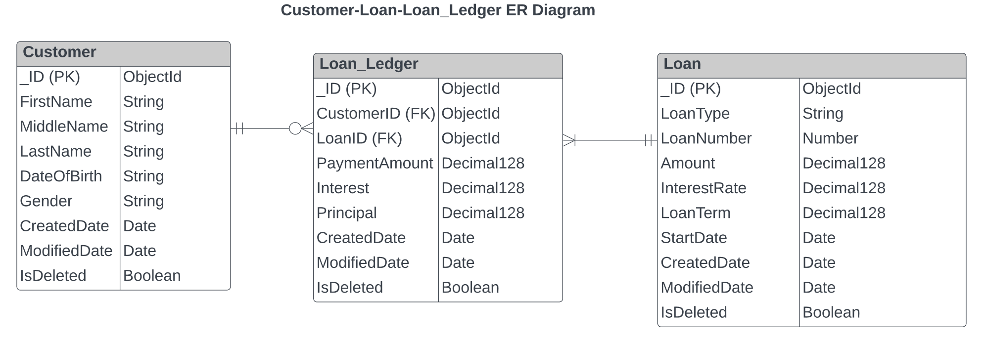

**Entity-Relationship Diagram Description:**

* **Customer Table:** The Customer Table is a database table that stores information about customers. It includes attributes such as the customer's full name, date of birth, gender, and the date when the customer record was created and last modified. Each record in this table is uniquely identified by an attribute called "_id," which serves as the primary key.
* **Loan Table:** The Loan Table is another database table that holds data related to loans. It contains attributes like the type of loan, loan number, loan amount, the interest rate charged, and the dates when the loan record was created and last modified. Similar to the Customer Table, each record in this table is also identified by a primary key called "_id."
* **Loan_Ledger Table:** The Loan_Ledger Table serves as a record of payments made by customers to repay their loans. This table establishes relationships with the Customer and Loan tables using foreign keys, specifically "LoanId" and "CustomerId." These foreign keys link entries in the Loan_Ledger Table to the respective customer and loan records, allowing for the tracking of payments associated with specific loans and customers.
* **Mapping Between Customer and Loan_Ledger Tables**: Regarding the relationship between the Customer Table and the Loan_Ledger Table, it works as follows:
* Each customer can have multiple entries (rows) in the Loan_Ledger Table, representing multiple payments made by that customer.
* Conversely, each record in the Loan_Ledger Table must correspond to exactly one customer.
* **Mapping Between Loan and Loan_Ledger Tables:** Concerning the relationship between the Loan Table and the Loan_Ledger Table:
* Each loan can be associated with multiple entries (rows) in the Loan_Ledger Table, indicating multiple payments received for that loan.
* Similarly, each record in the Loan_Ledger Table must be linked to precisely one loan.
* In summary, this ER diagram describes a database structure for managing customer information, loan details, and loan payment records. It enforces specific relationships between these tables to maintain data integrity and enable effective tracking of payments made by customers toward their loans.

**Part 2: Requirement Storage Design Implementation: (DATABASE)**

**Created a database “LOANS” in mongoDB:**

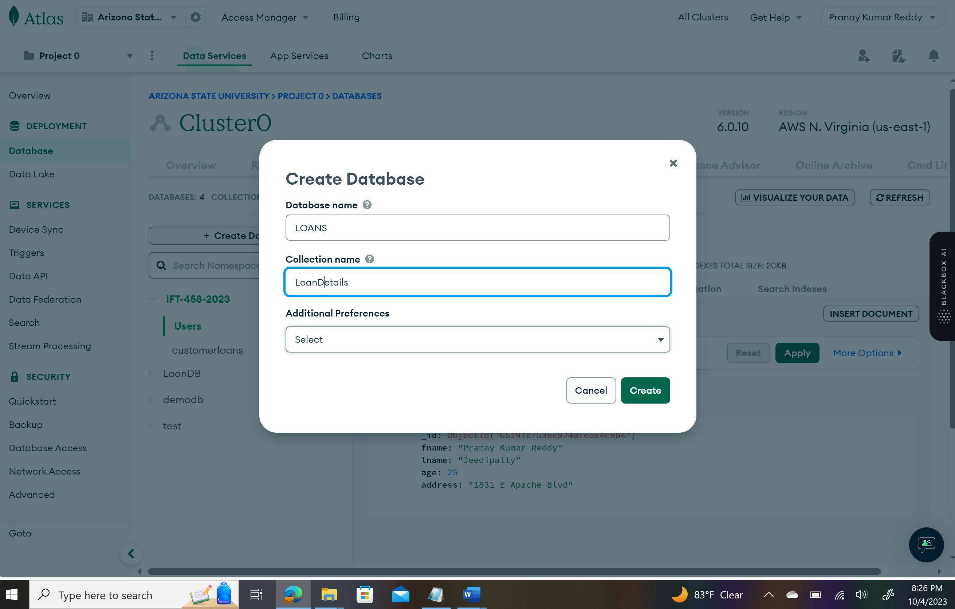

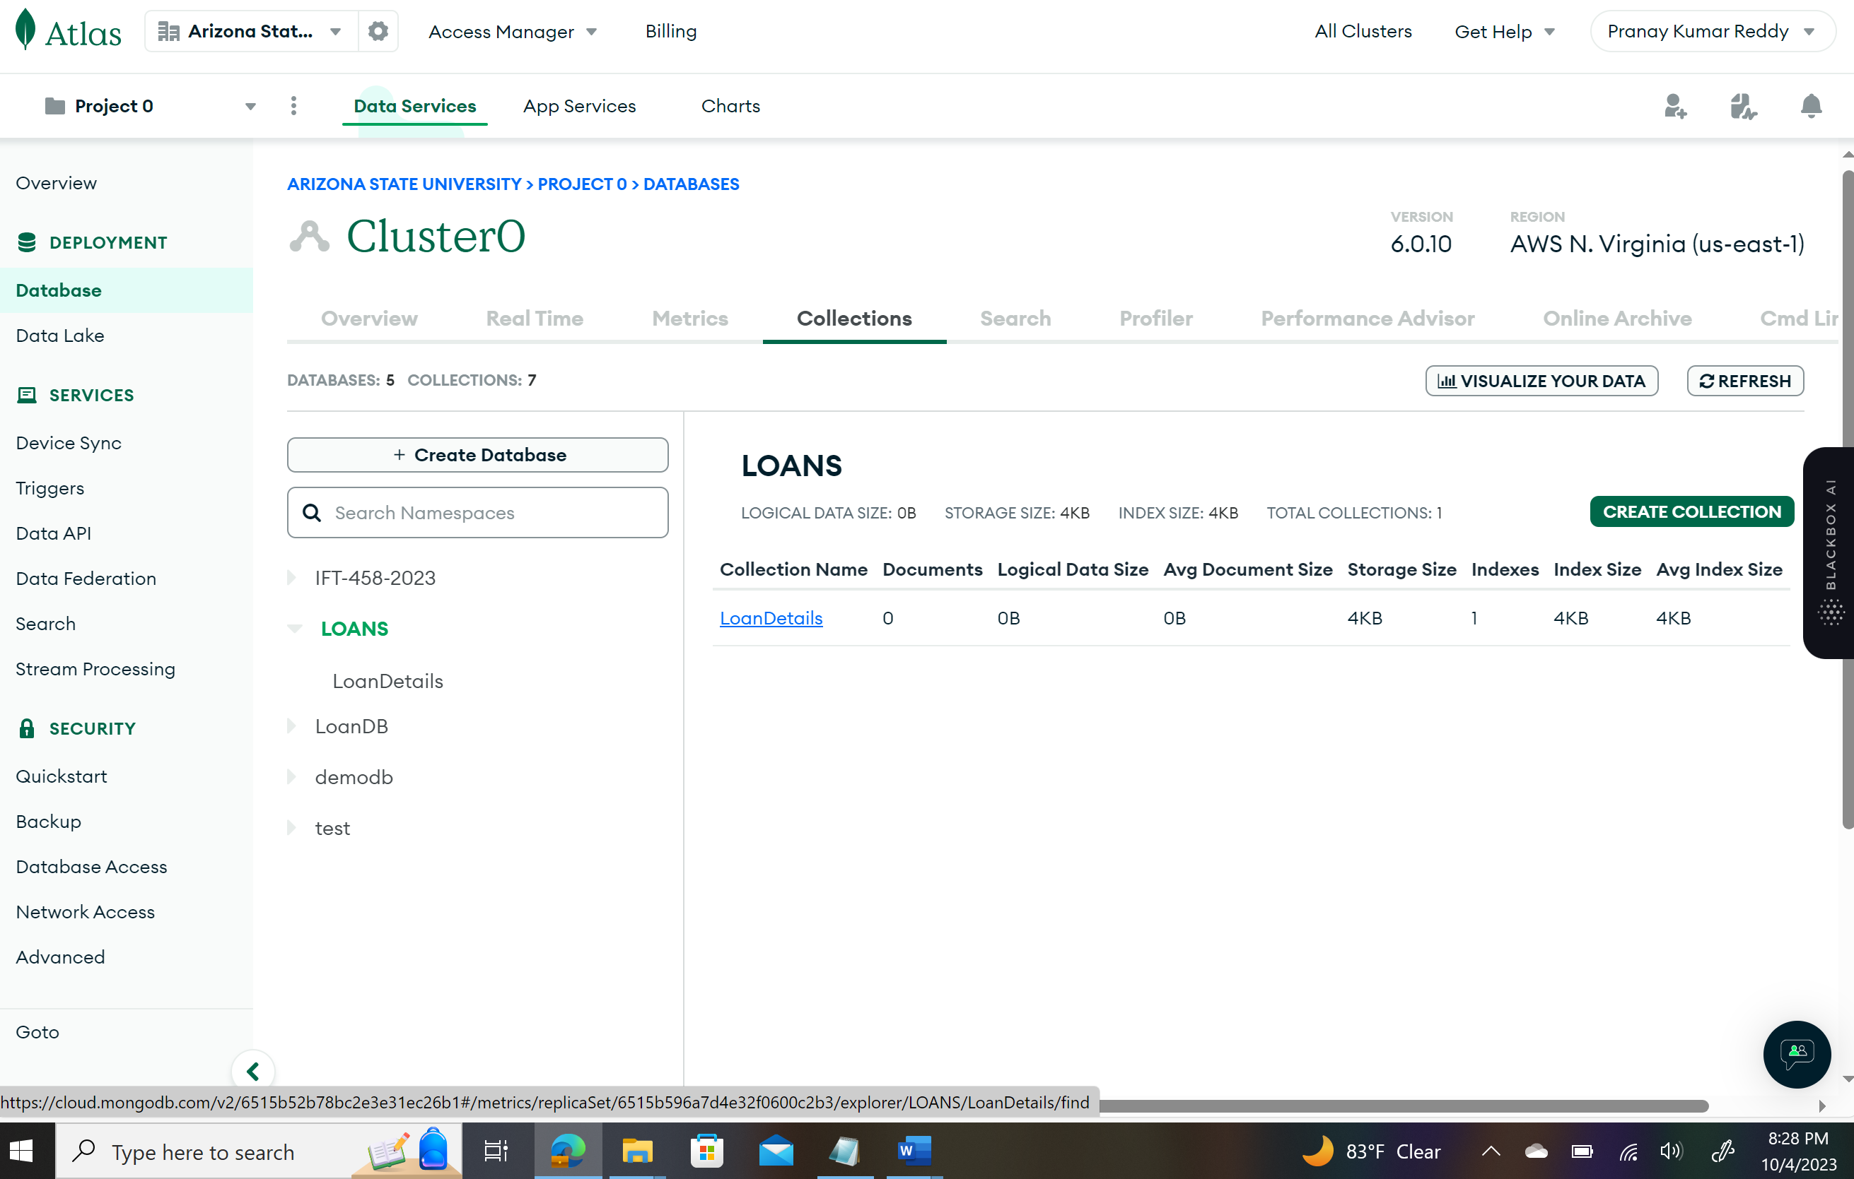

**customerModel.js:**

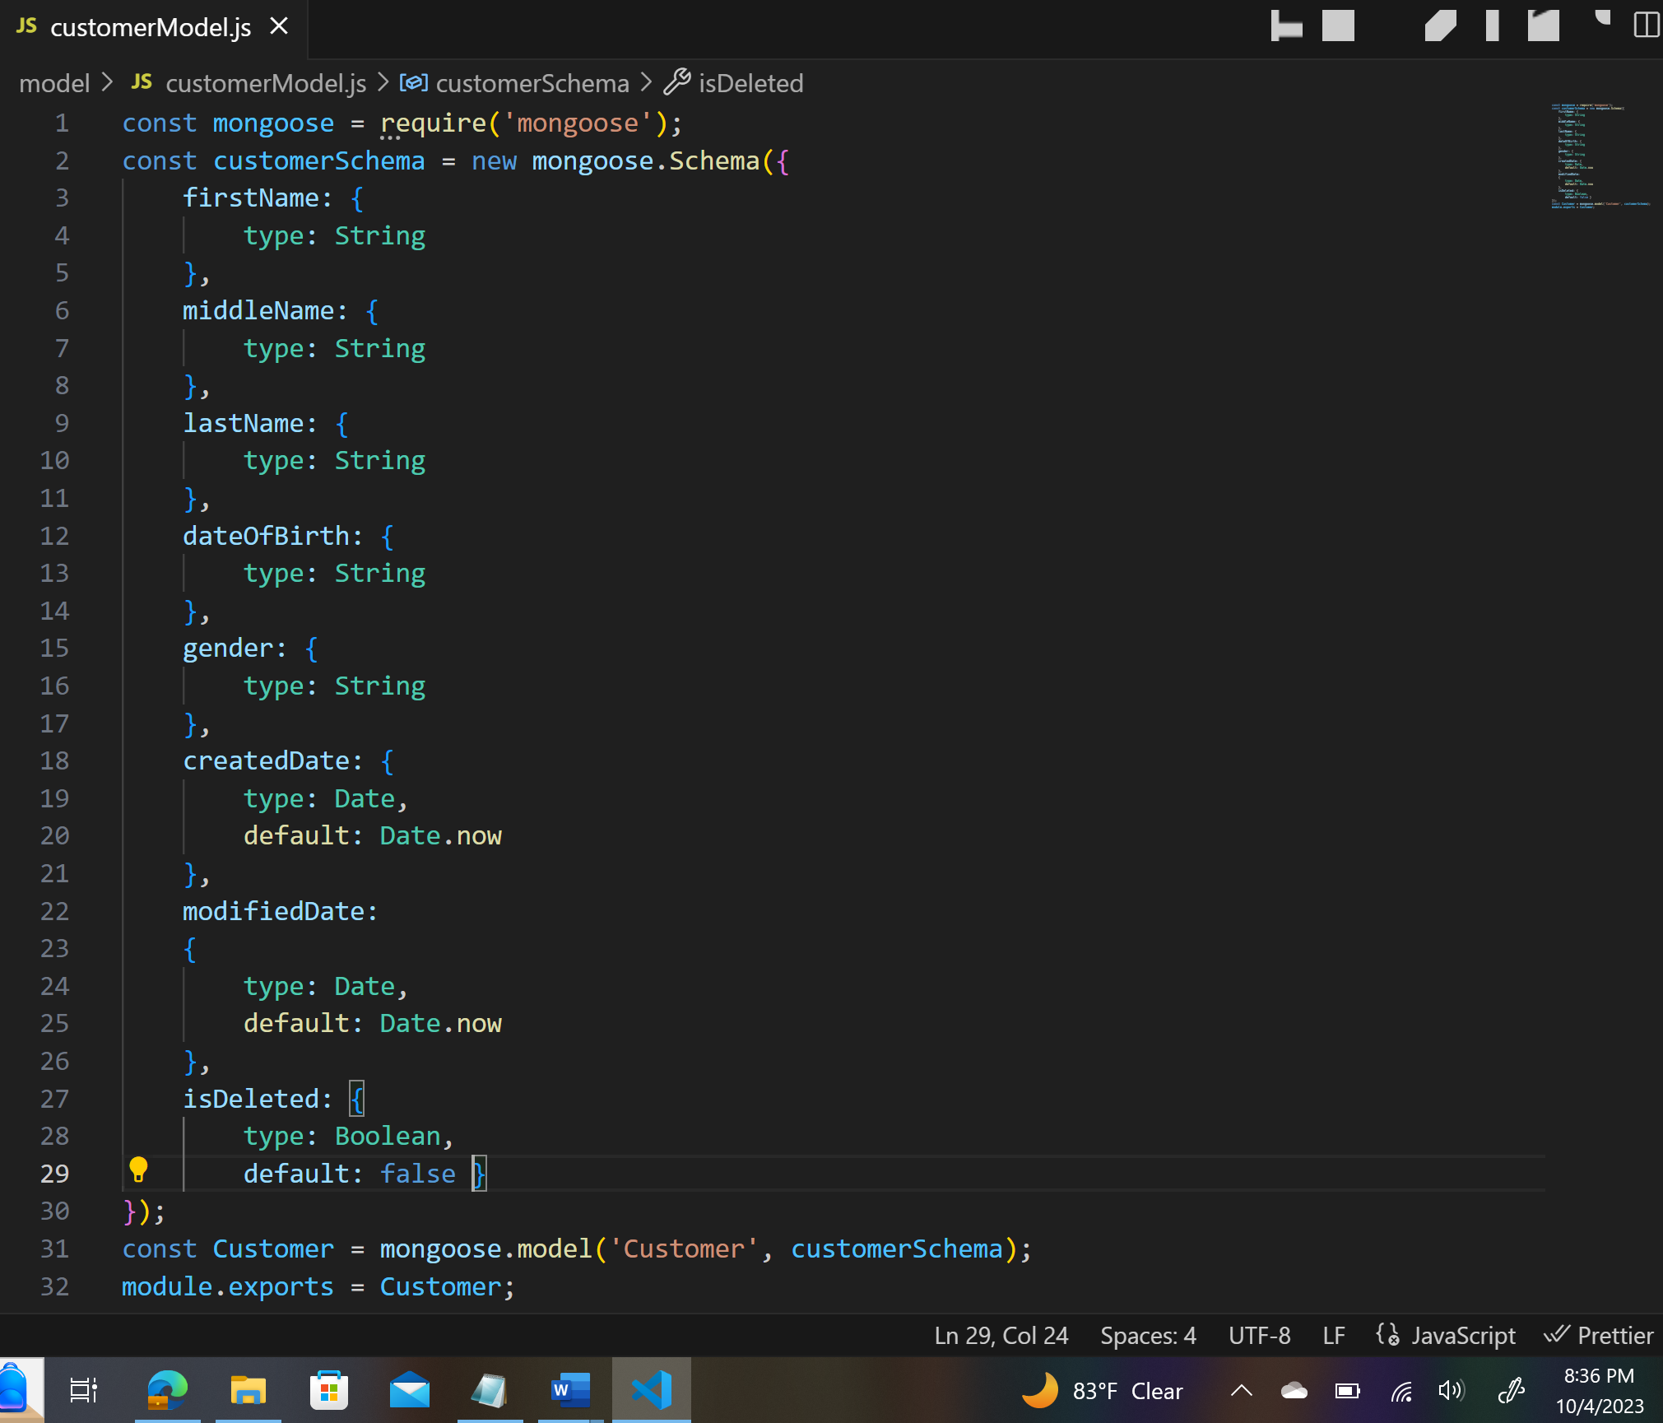

**loanLedgerModel.js:**

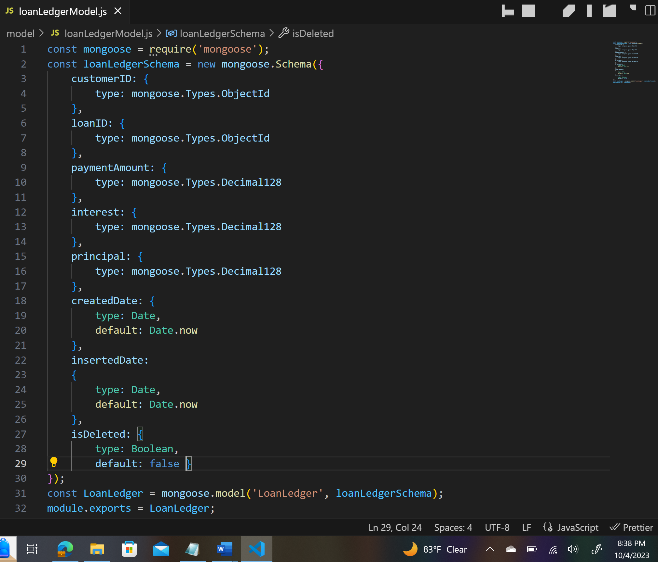

**loanModel.js:**

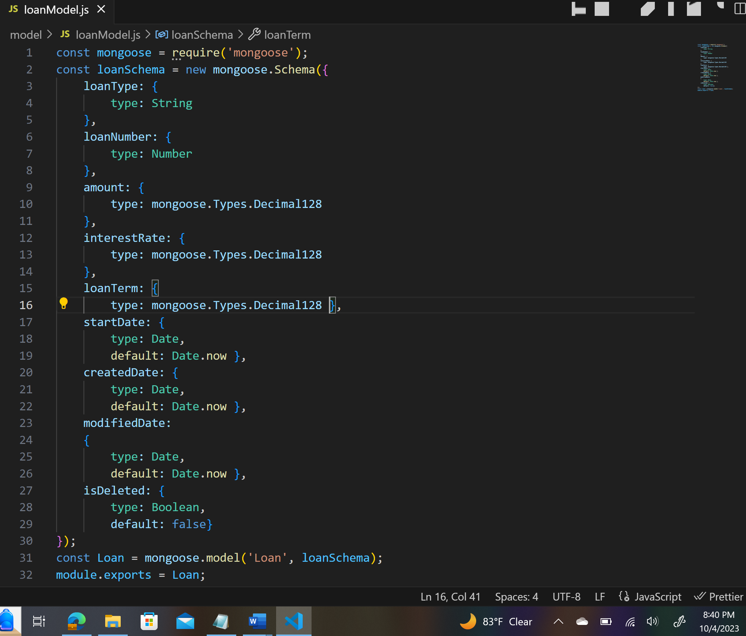

**App running with successful displaying the Port number and Listening:**

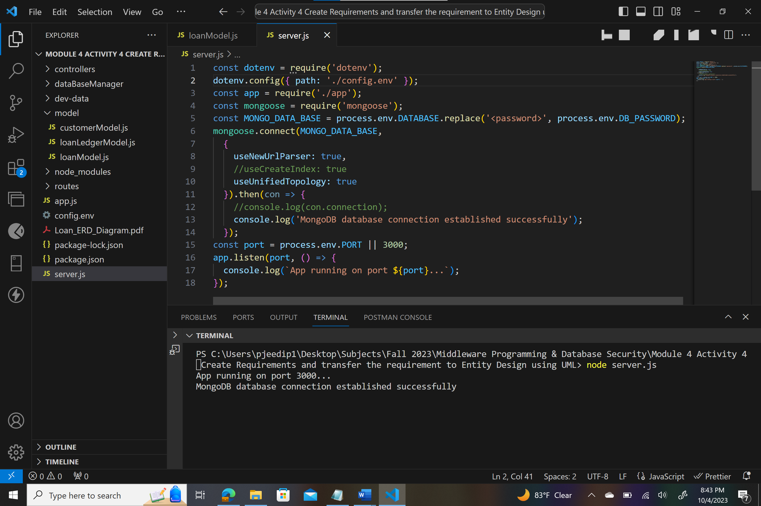

**Adding a Customer Loan Information and Testing in Postman:**

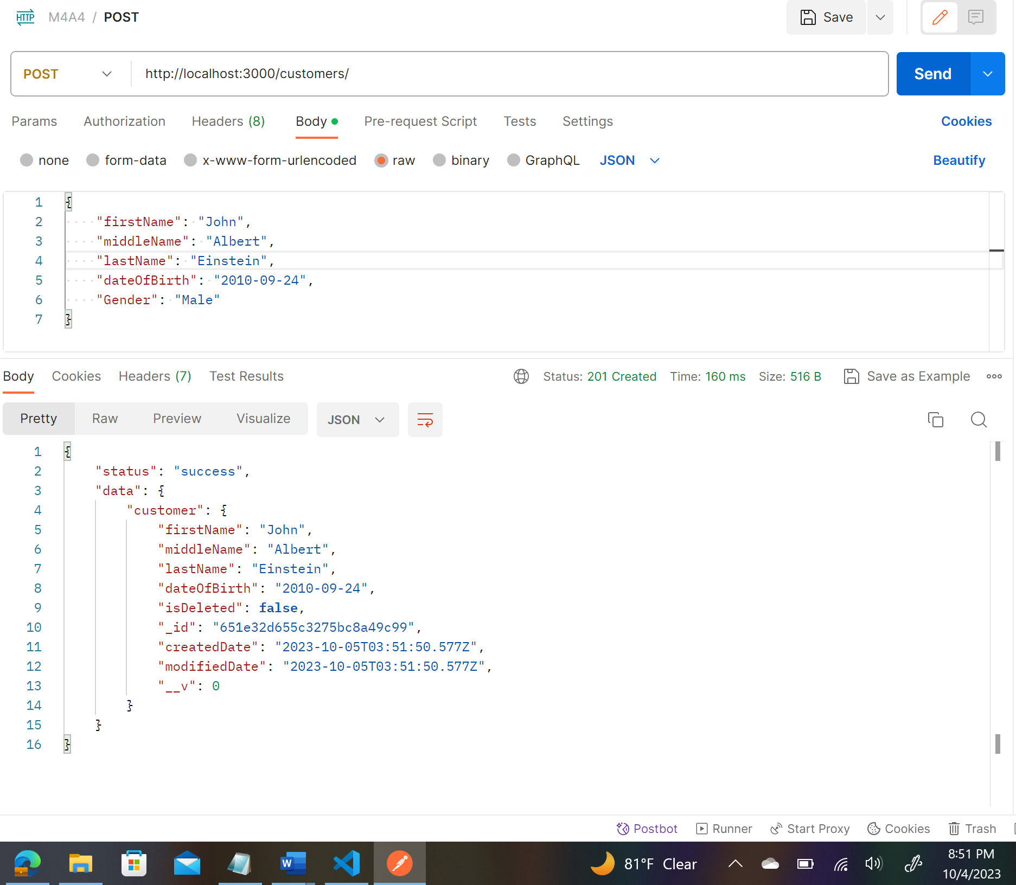

**Reflection to MongoDb:**

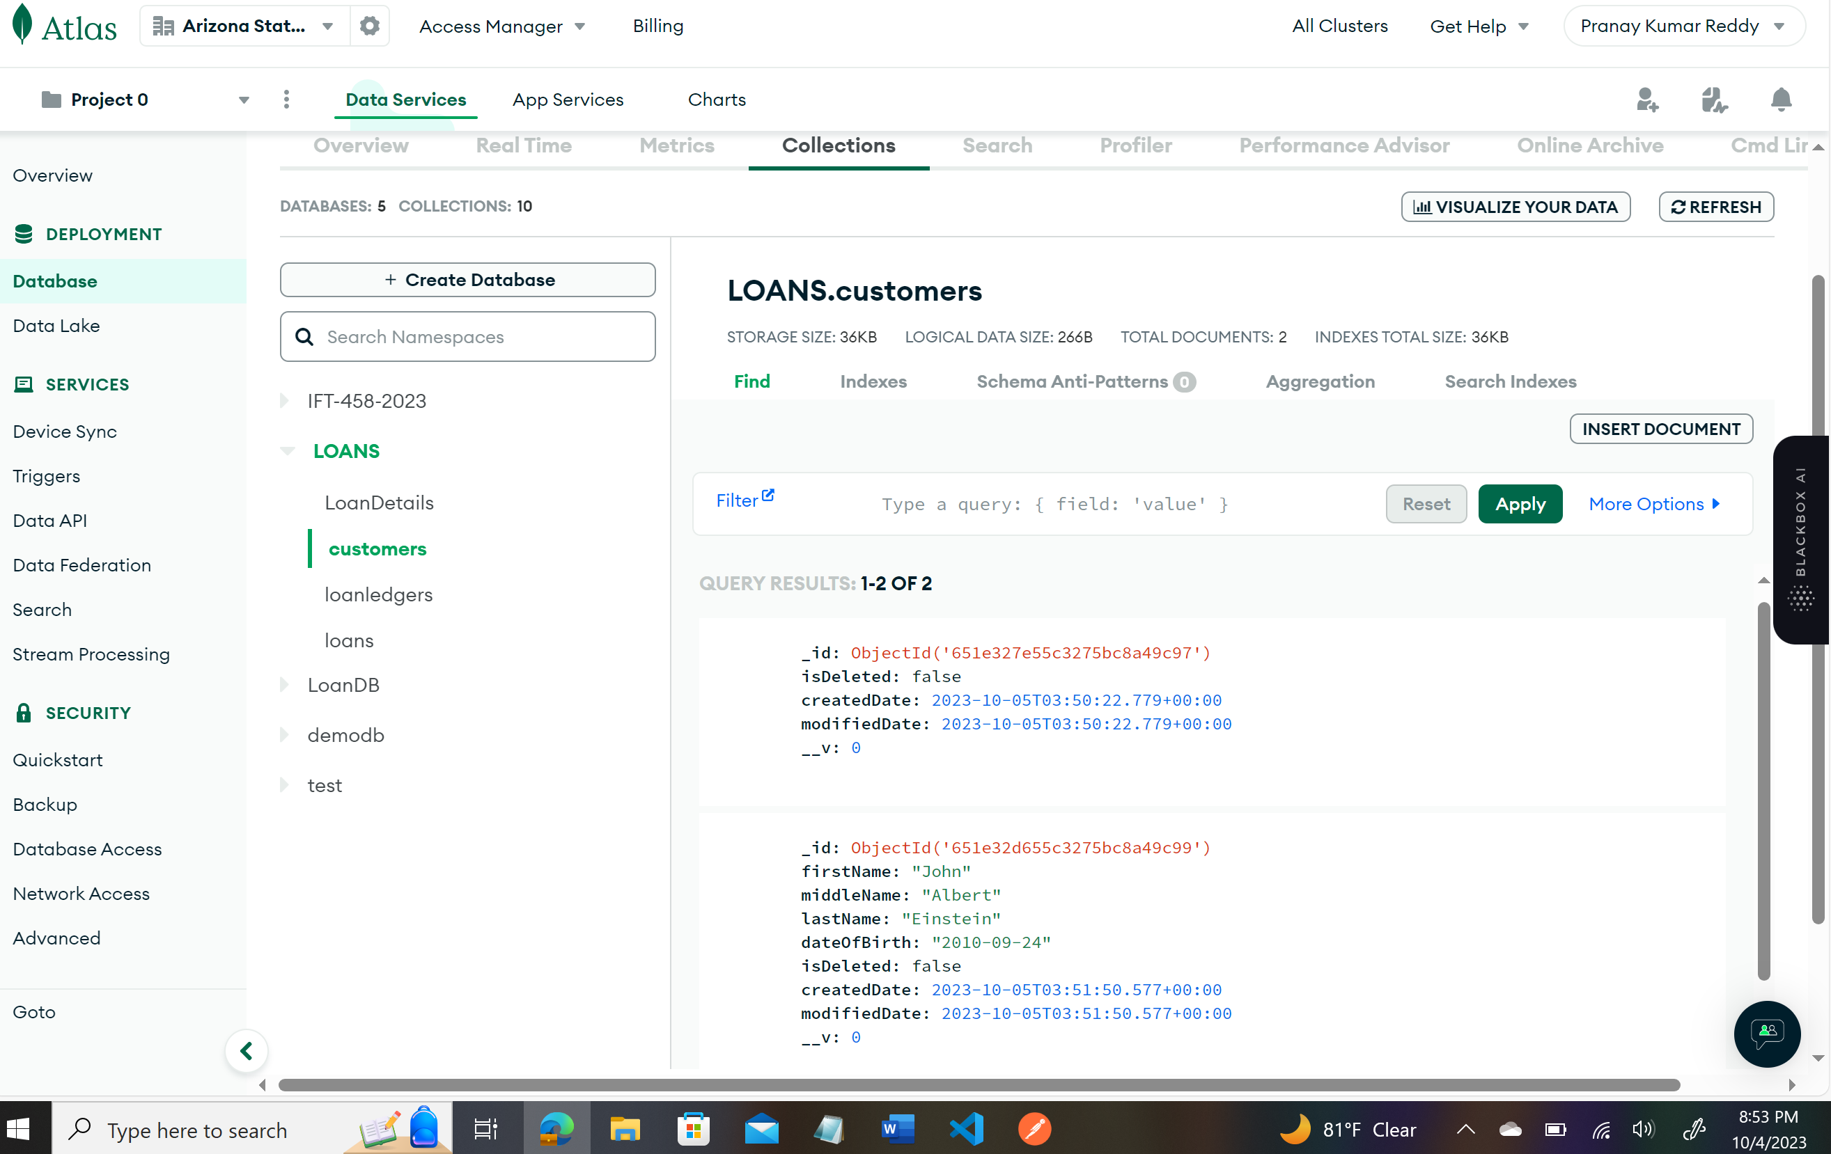

**Insert Records for 10 Customers**

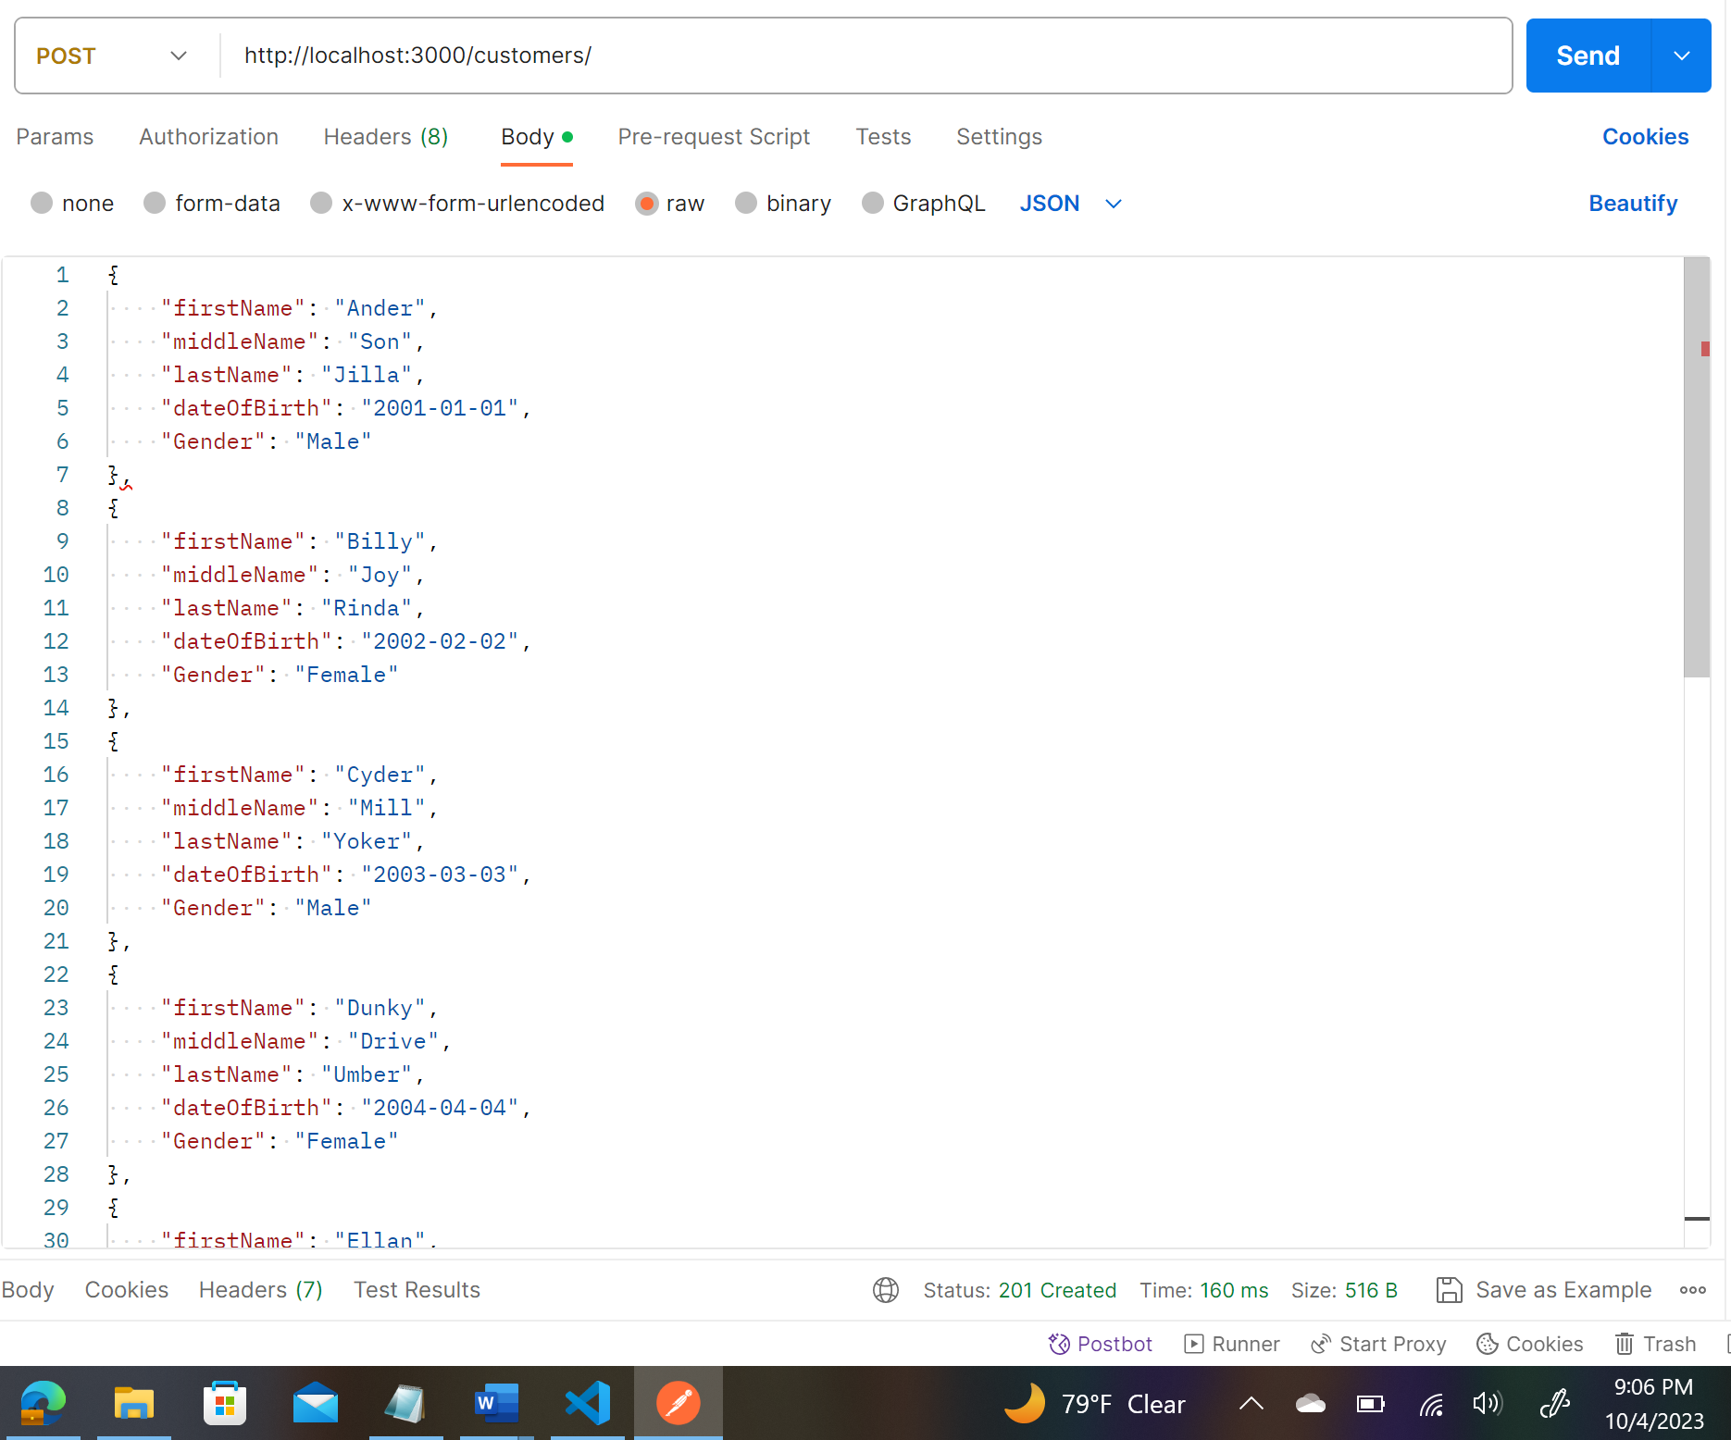

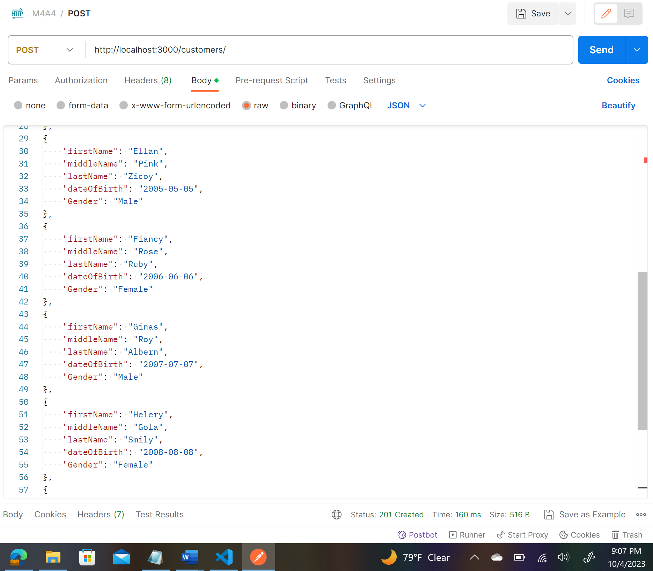

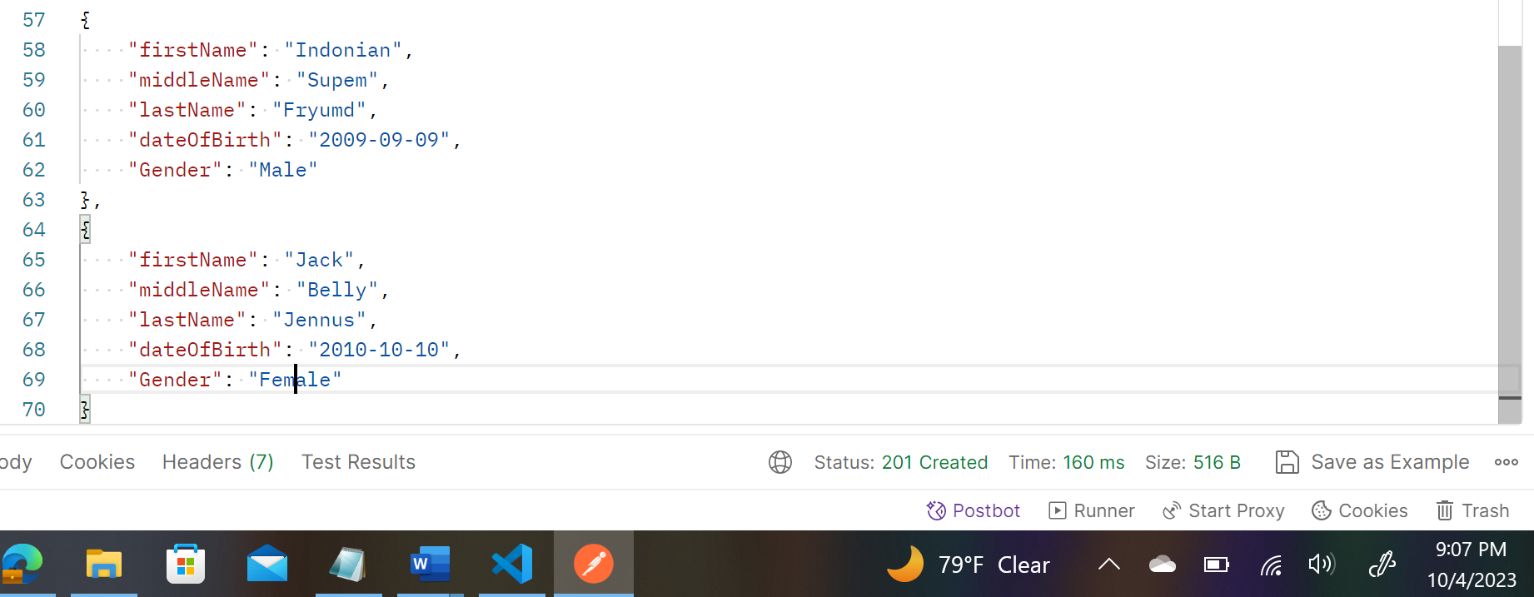

**Posted 10 Customer-Records:**

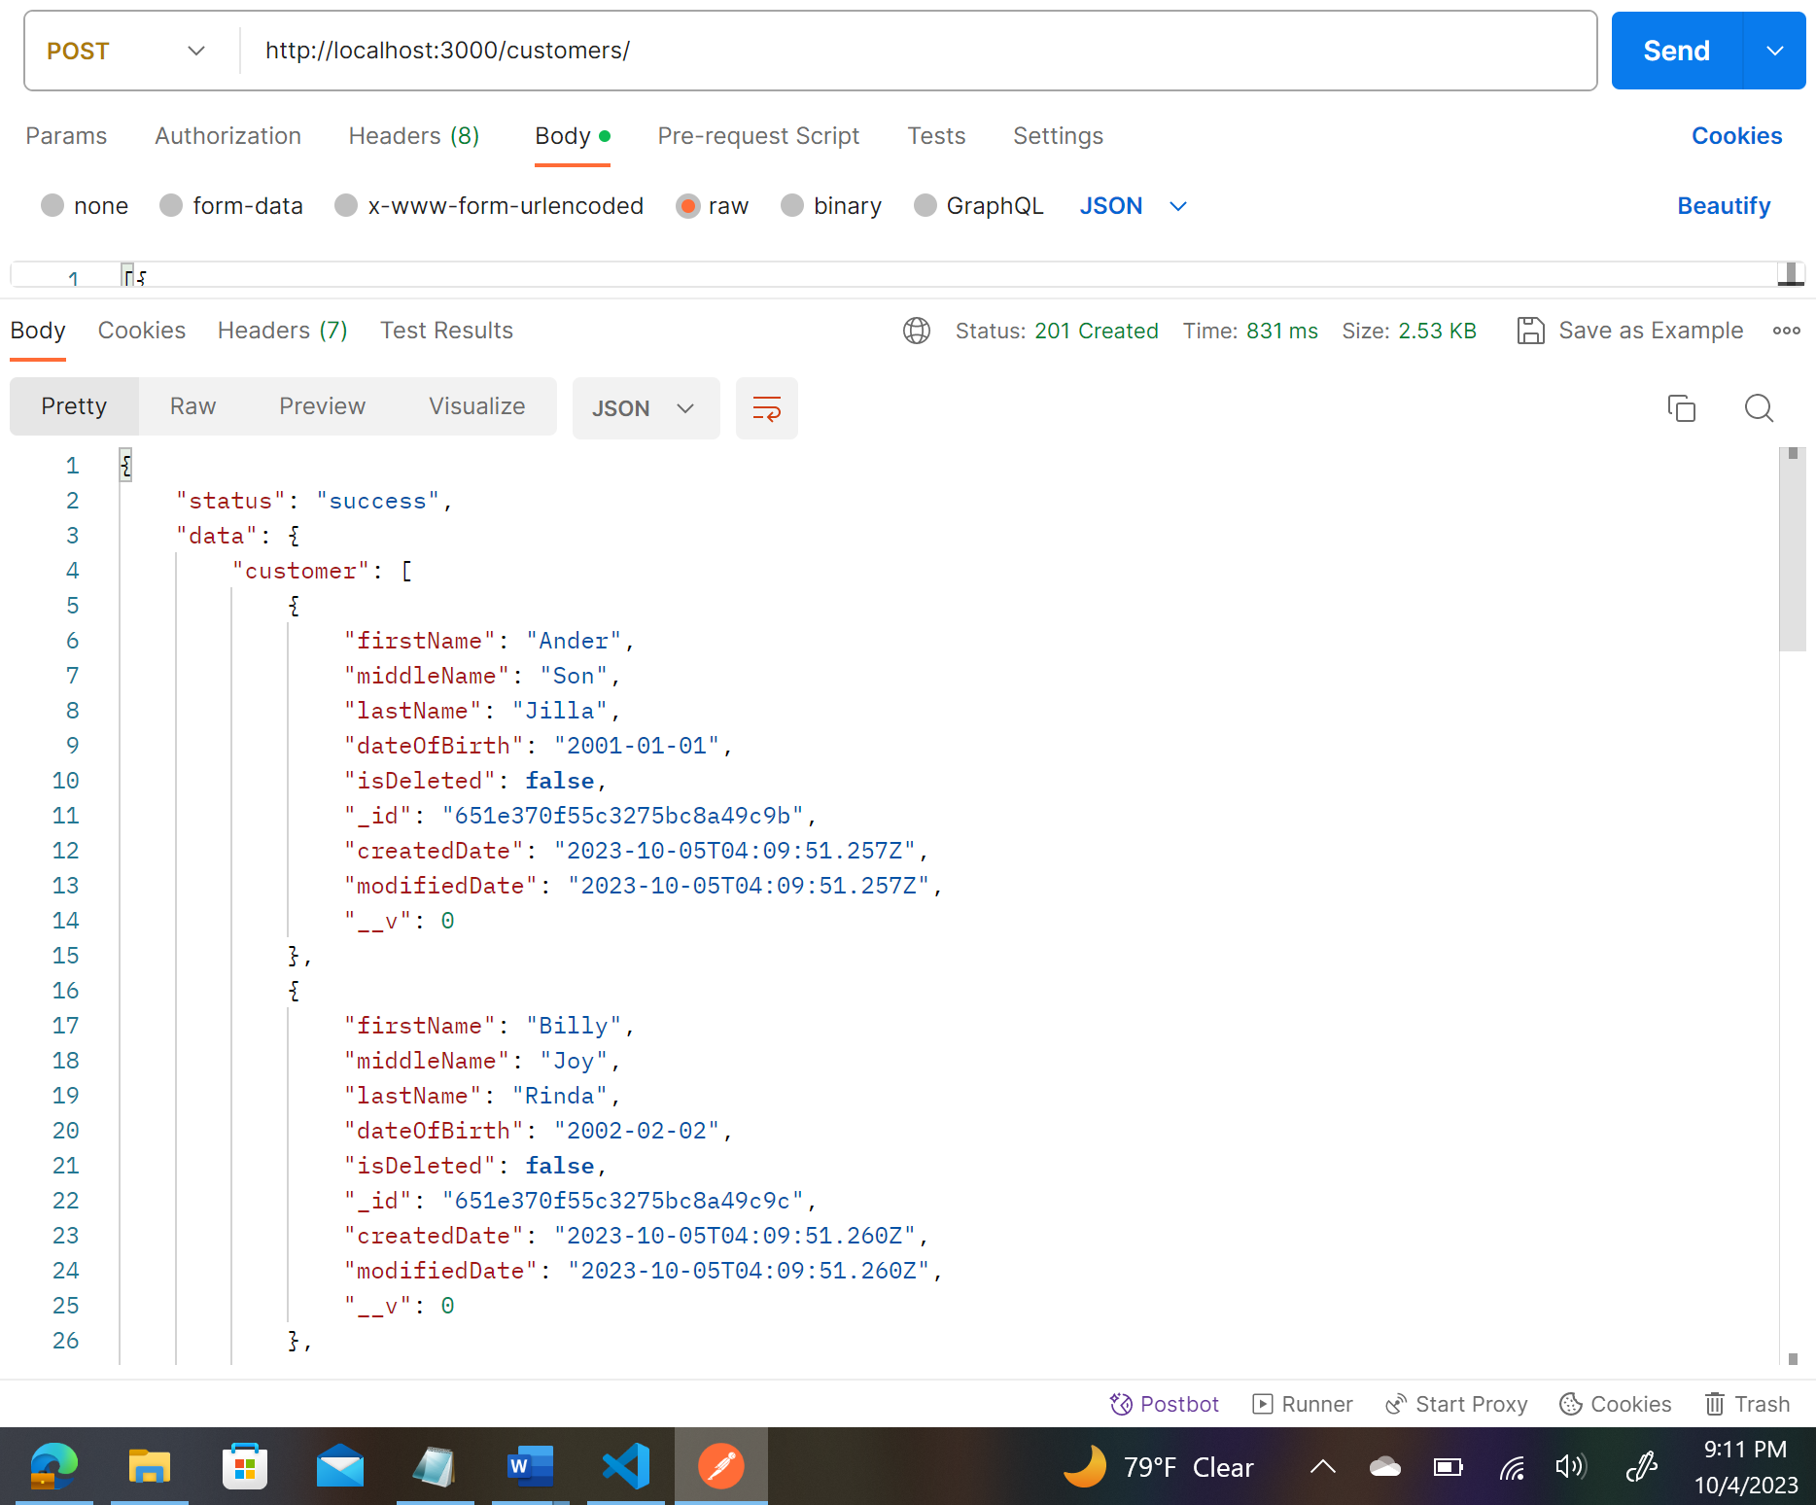

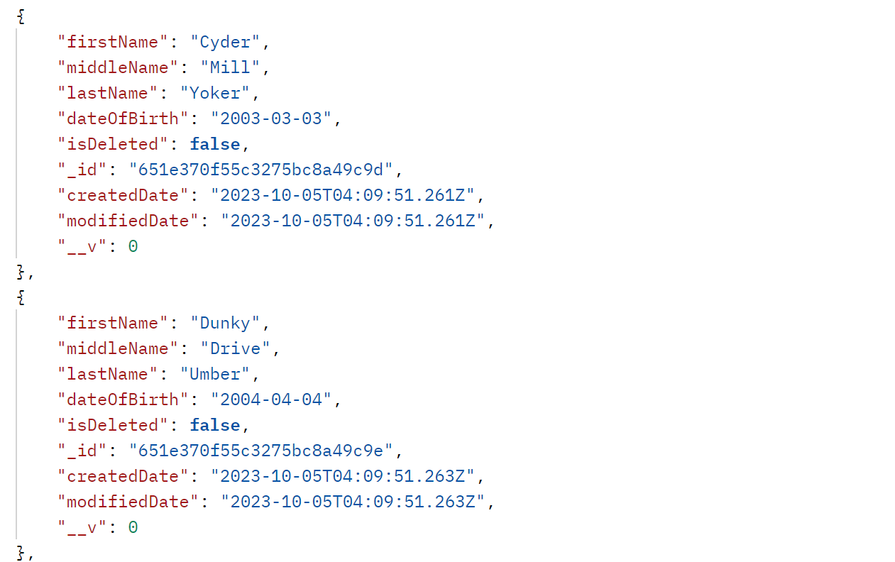

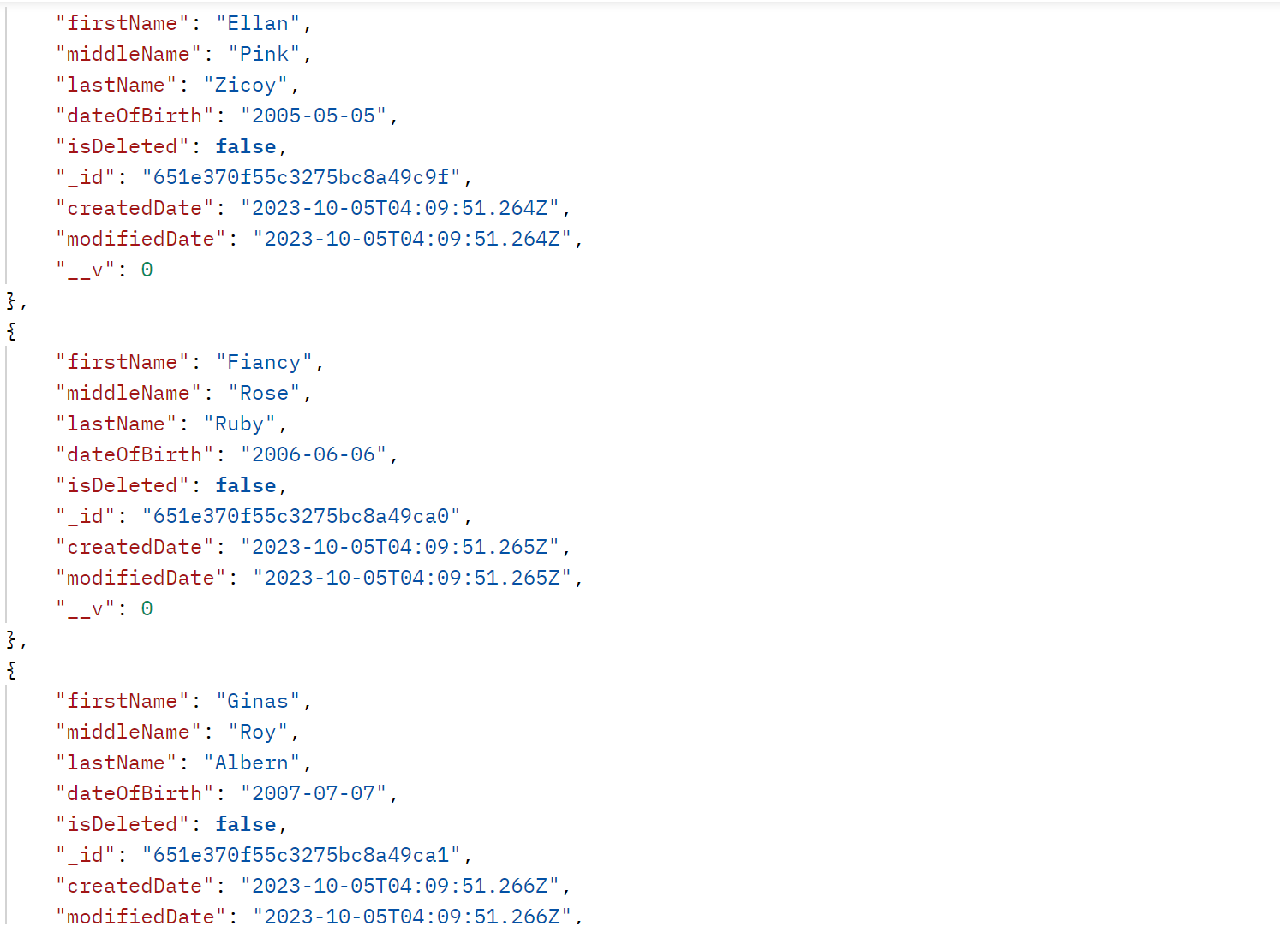

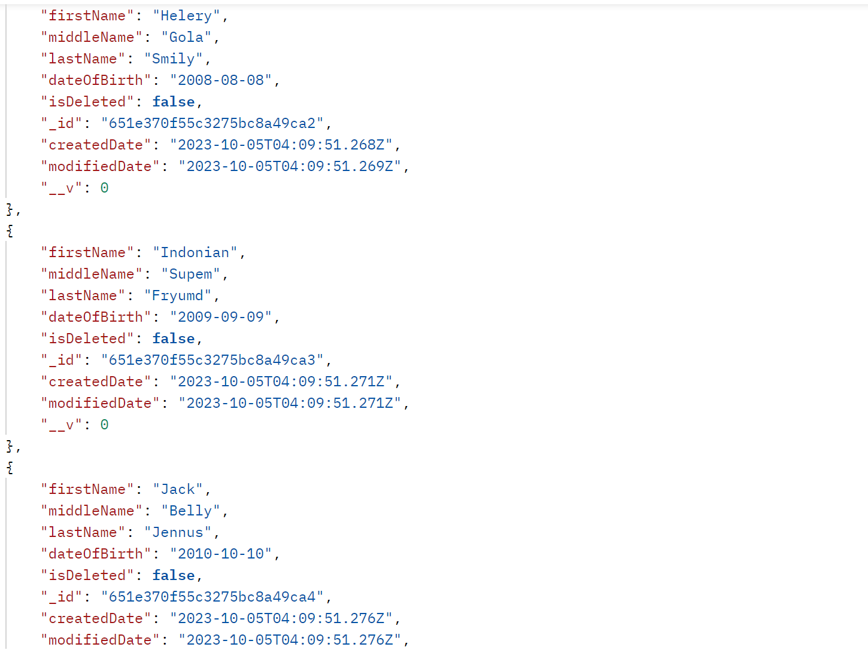

**Database Collections for 10 customers loan-records in MongoDb:**

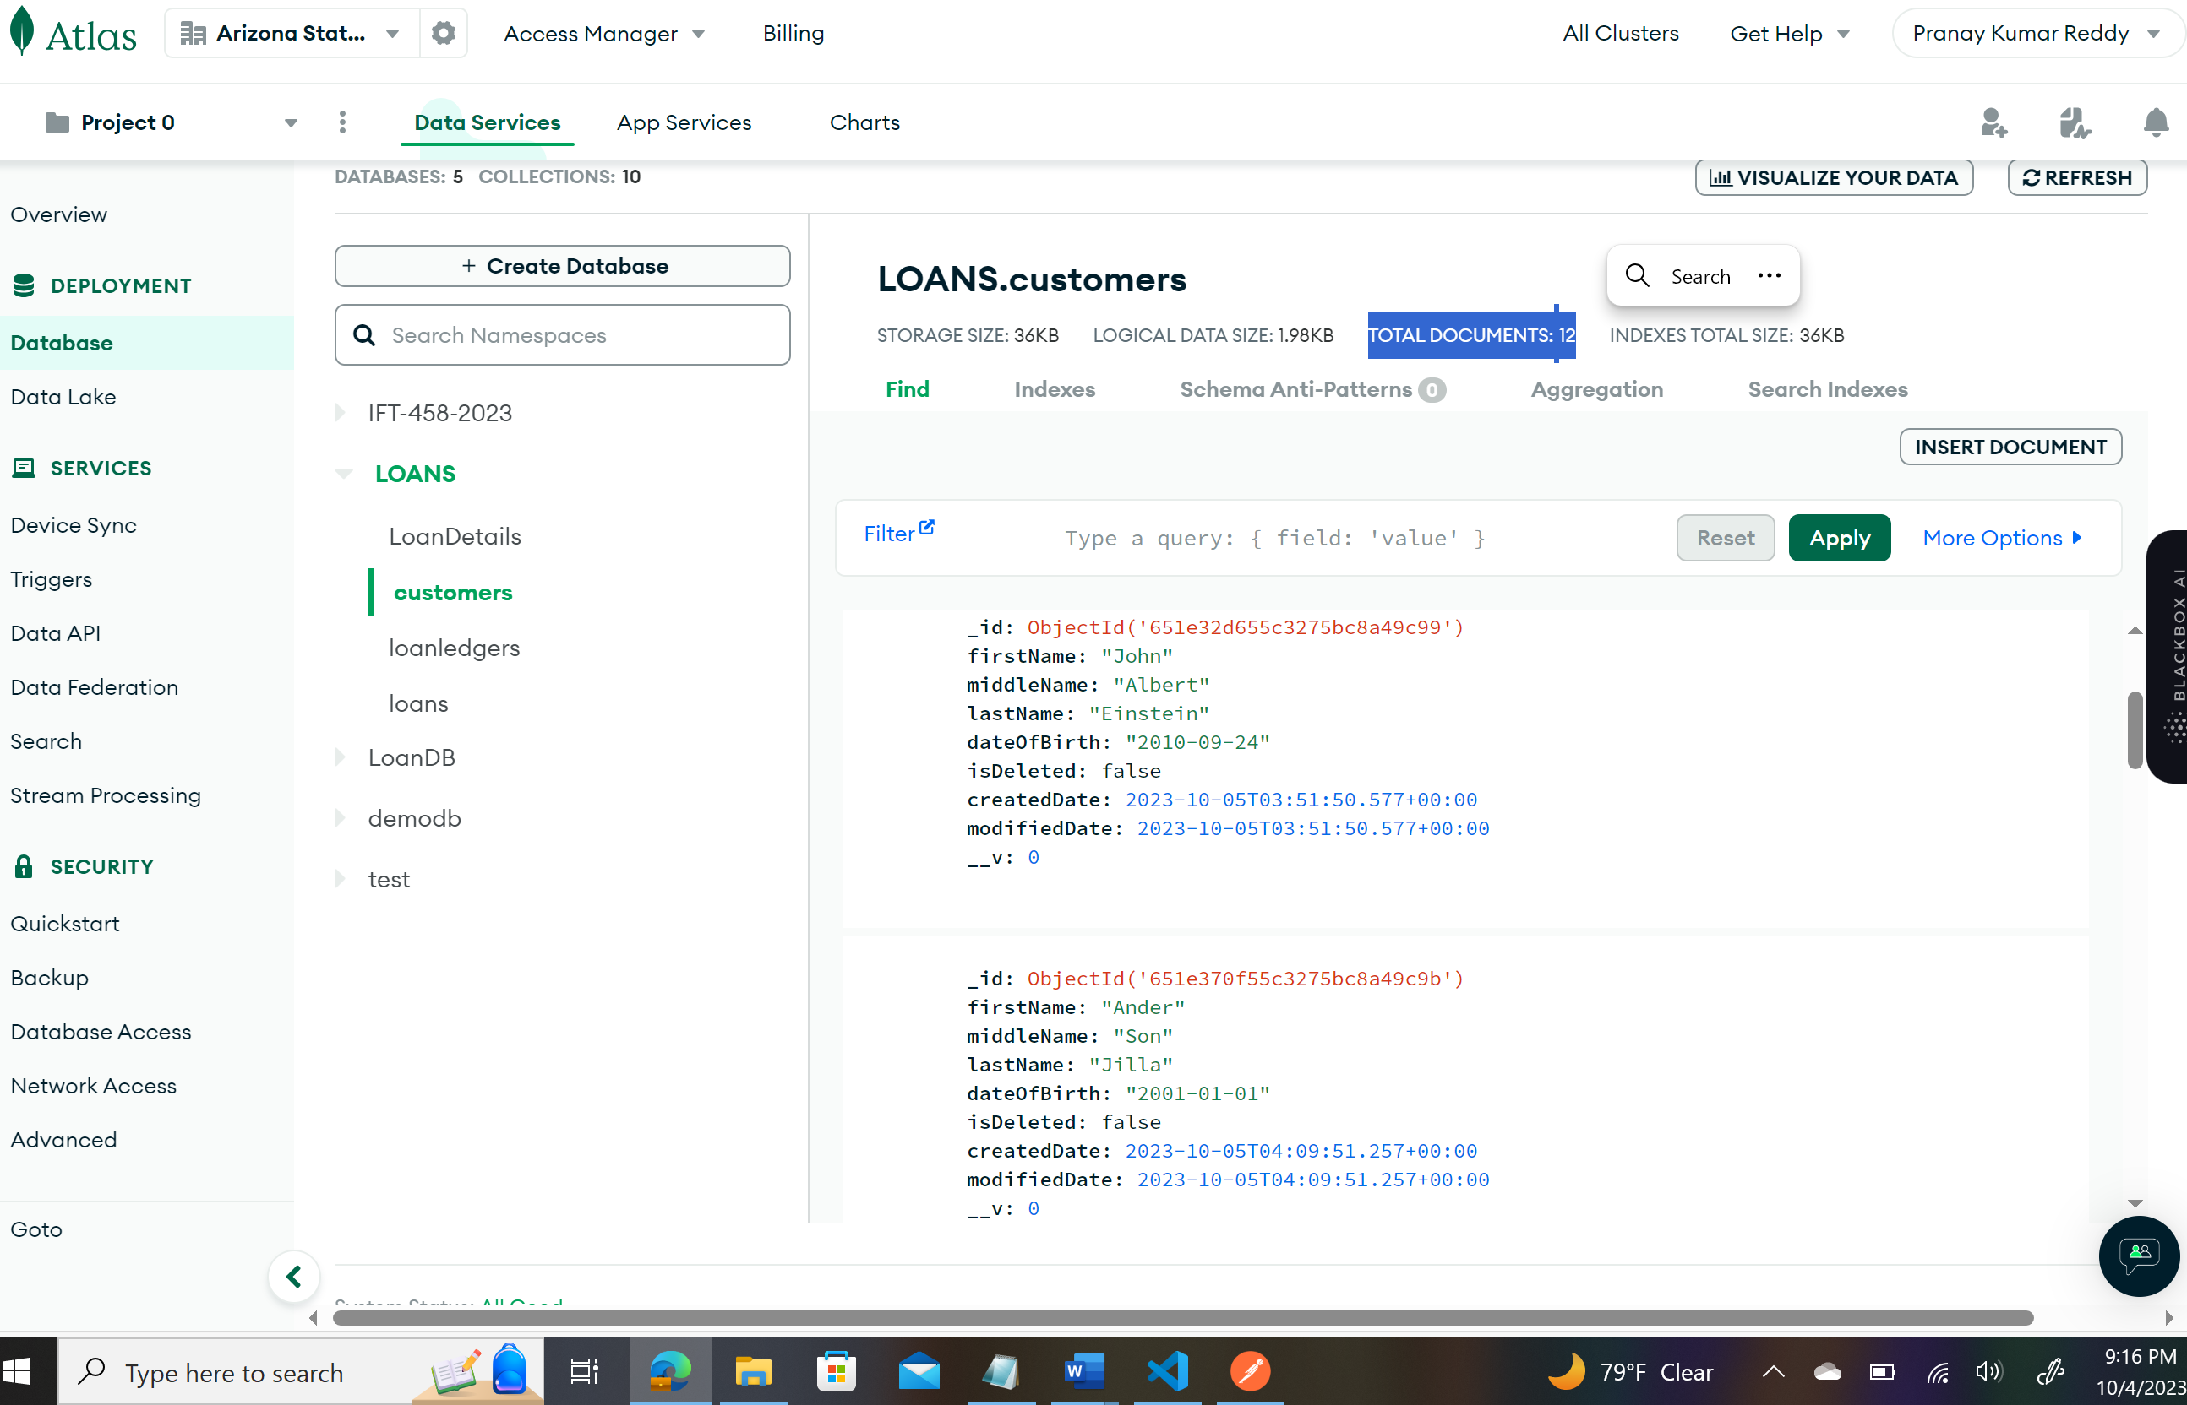

**Insert Records for 3 LoanTypes:**

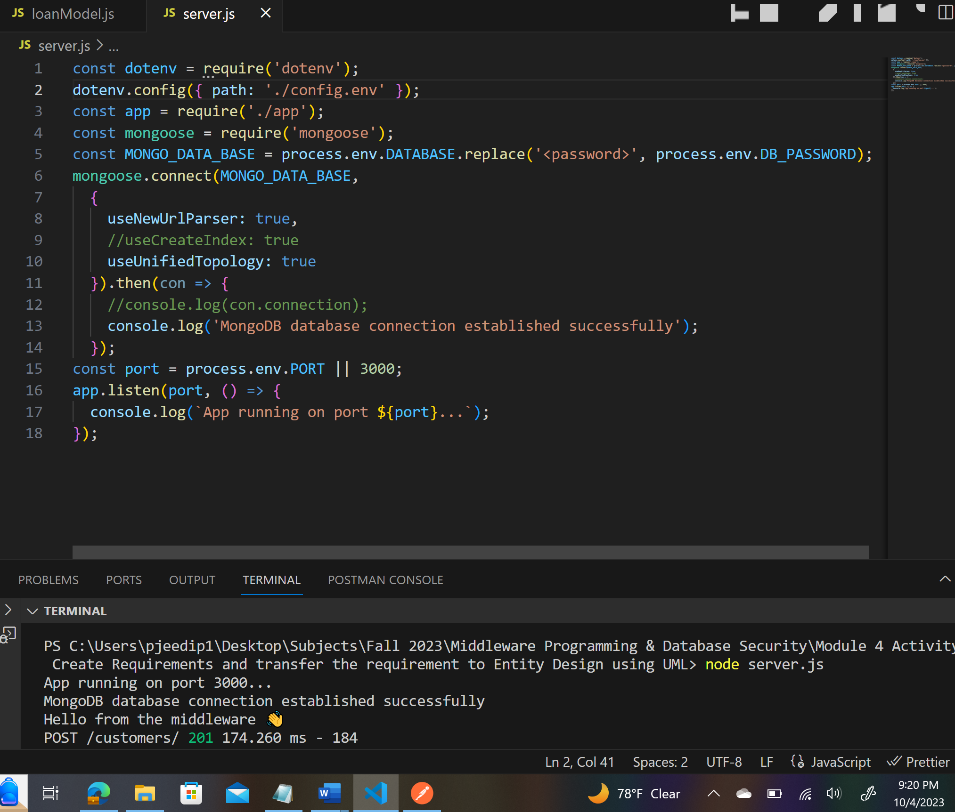

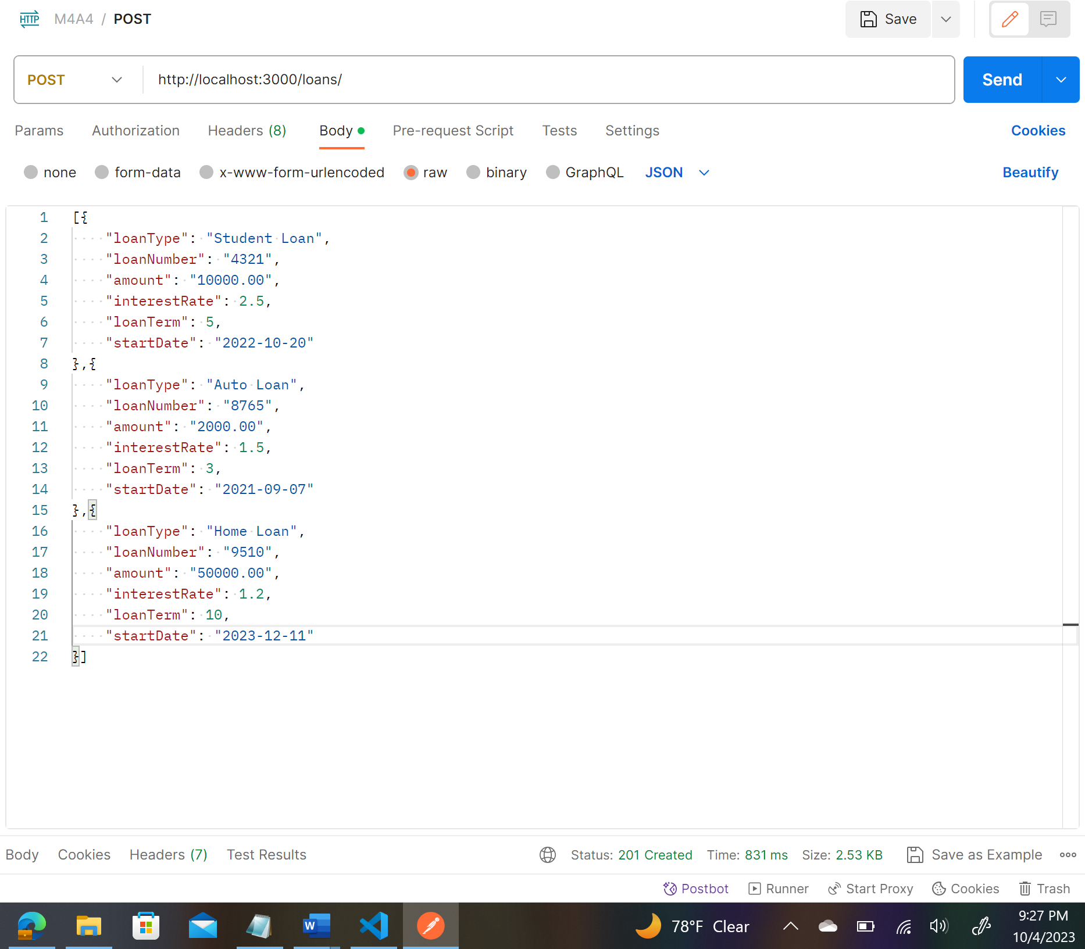

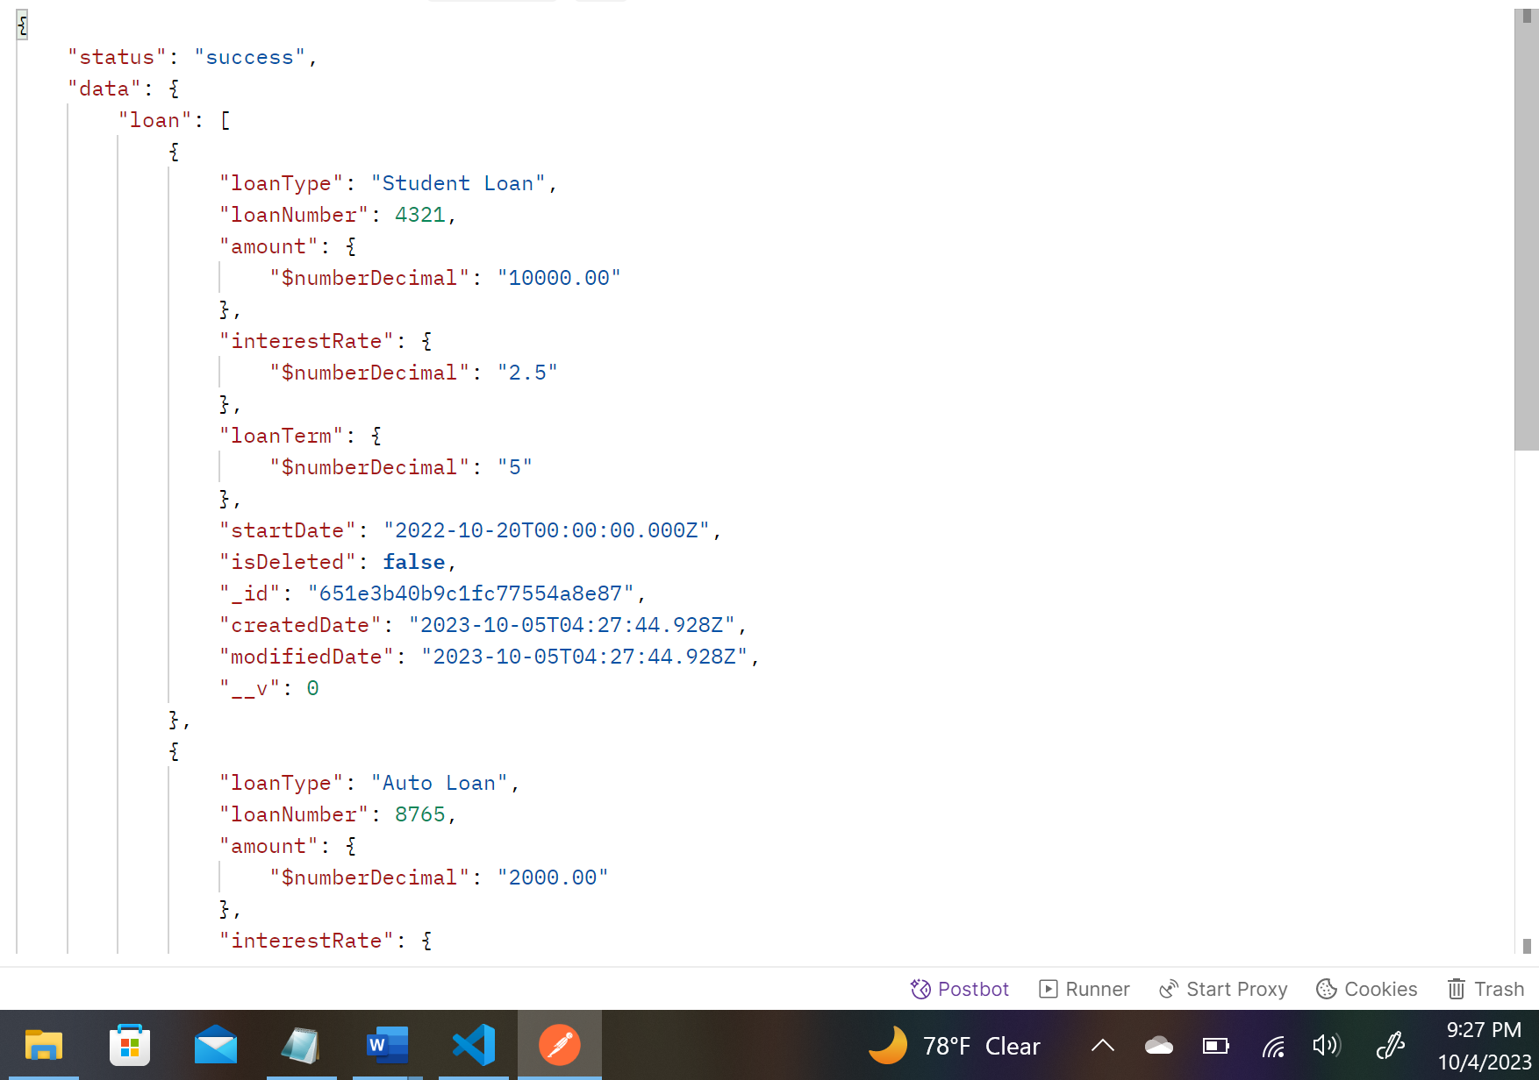

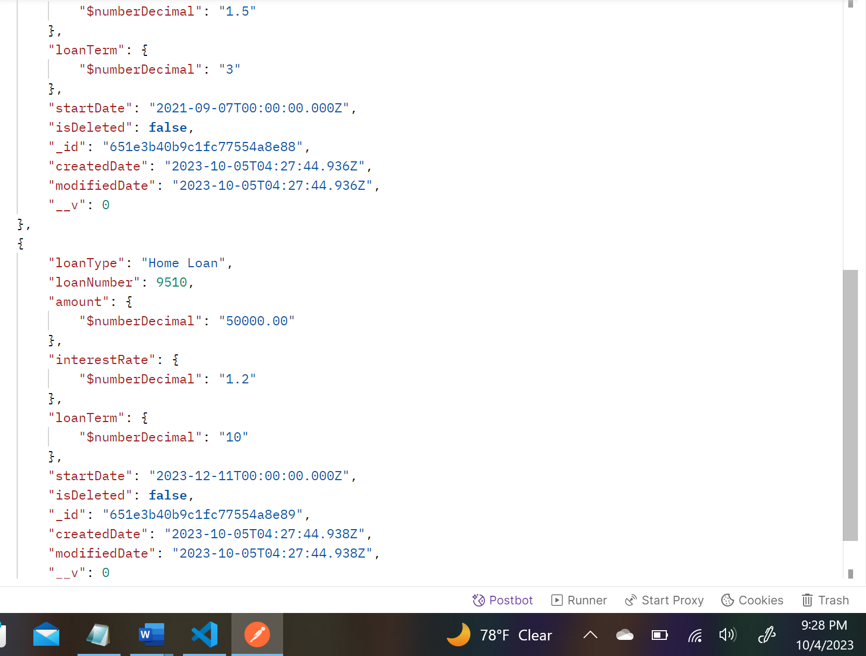

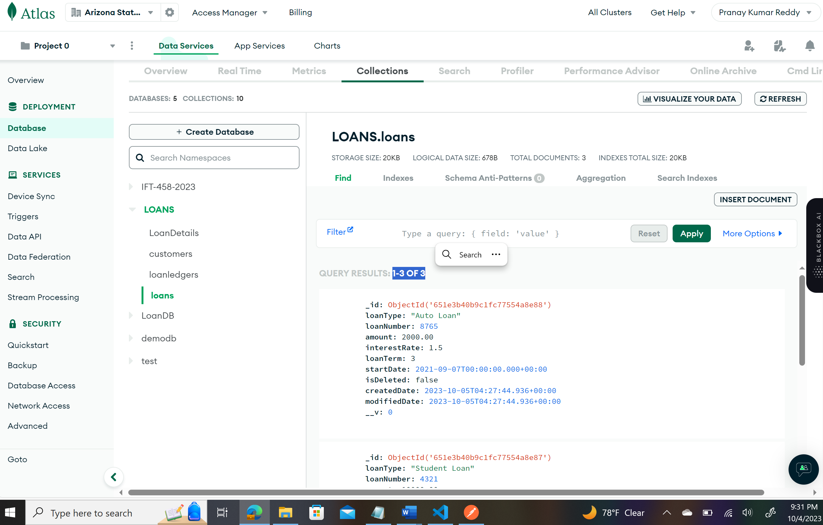

**Insert Records 2 Payments for 5 Customers with complete loan payments:**

**First Payment of 5 Customers:**

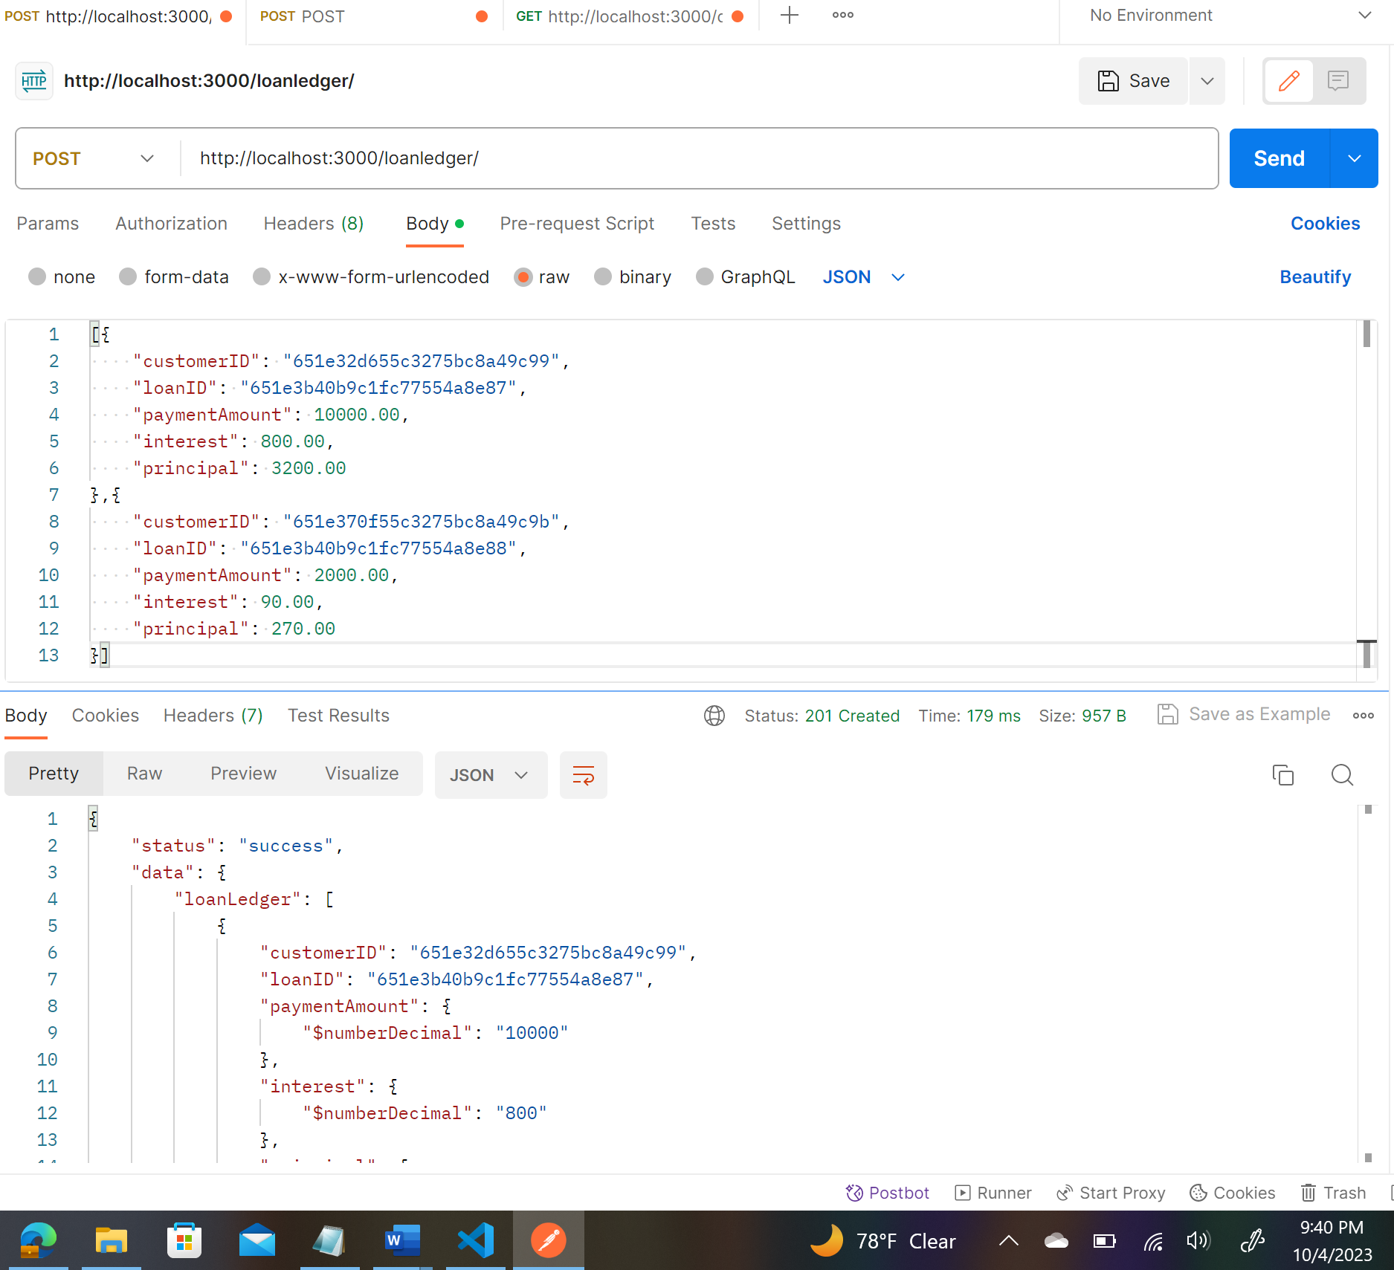

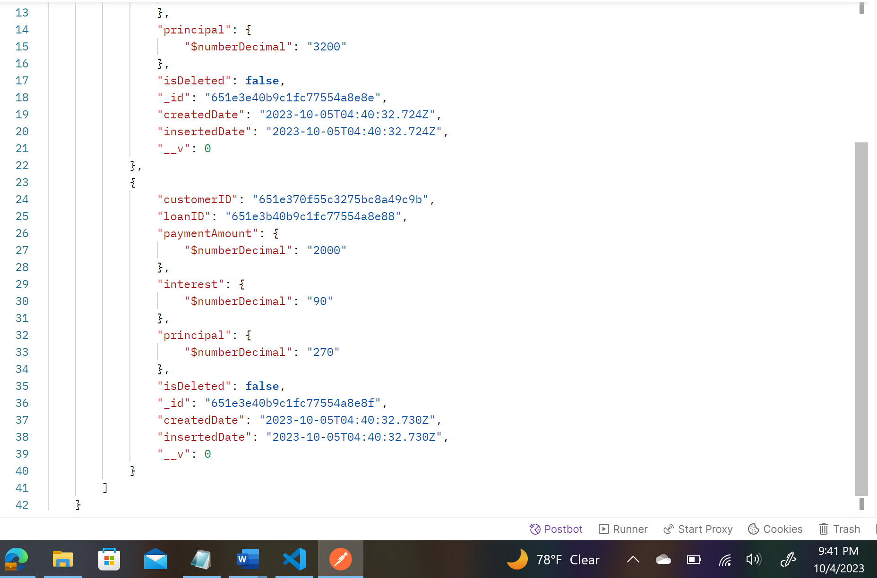

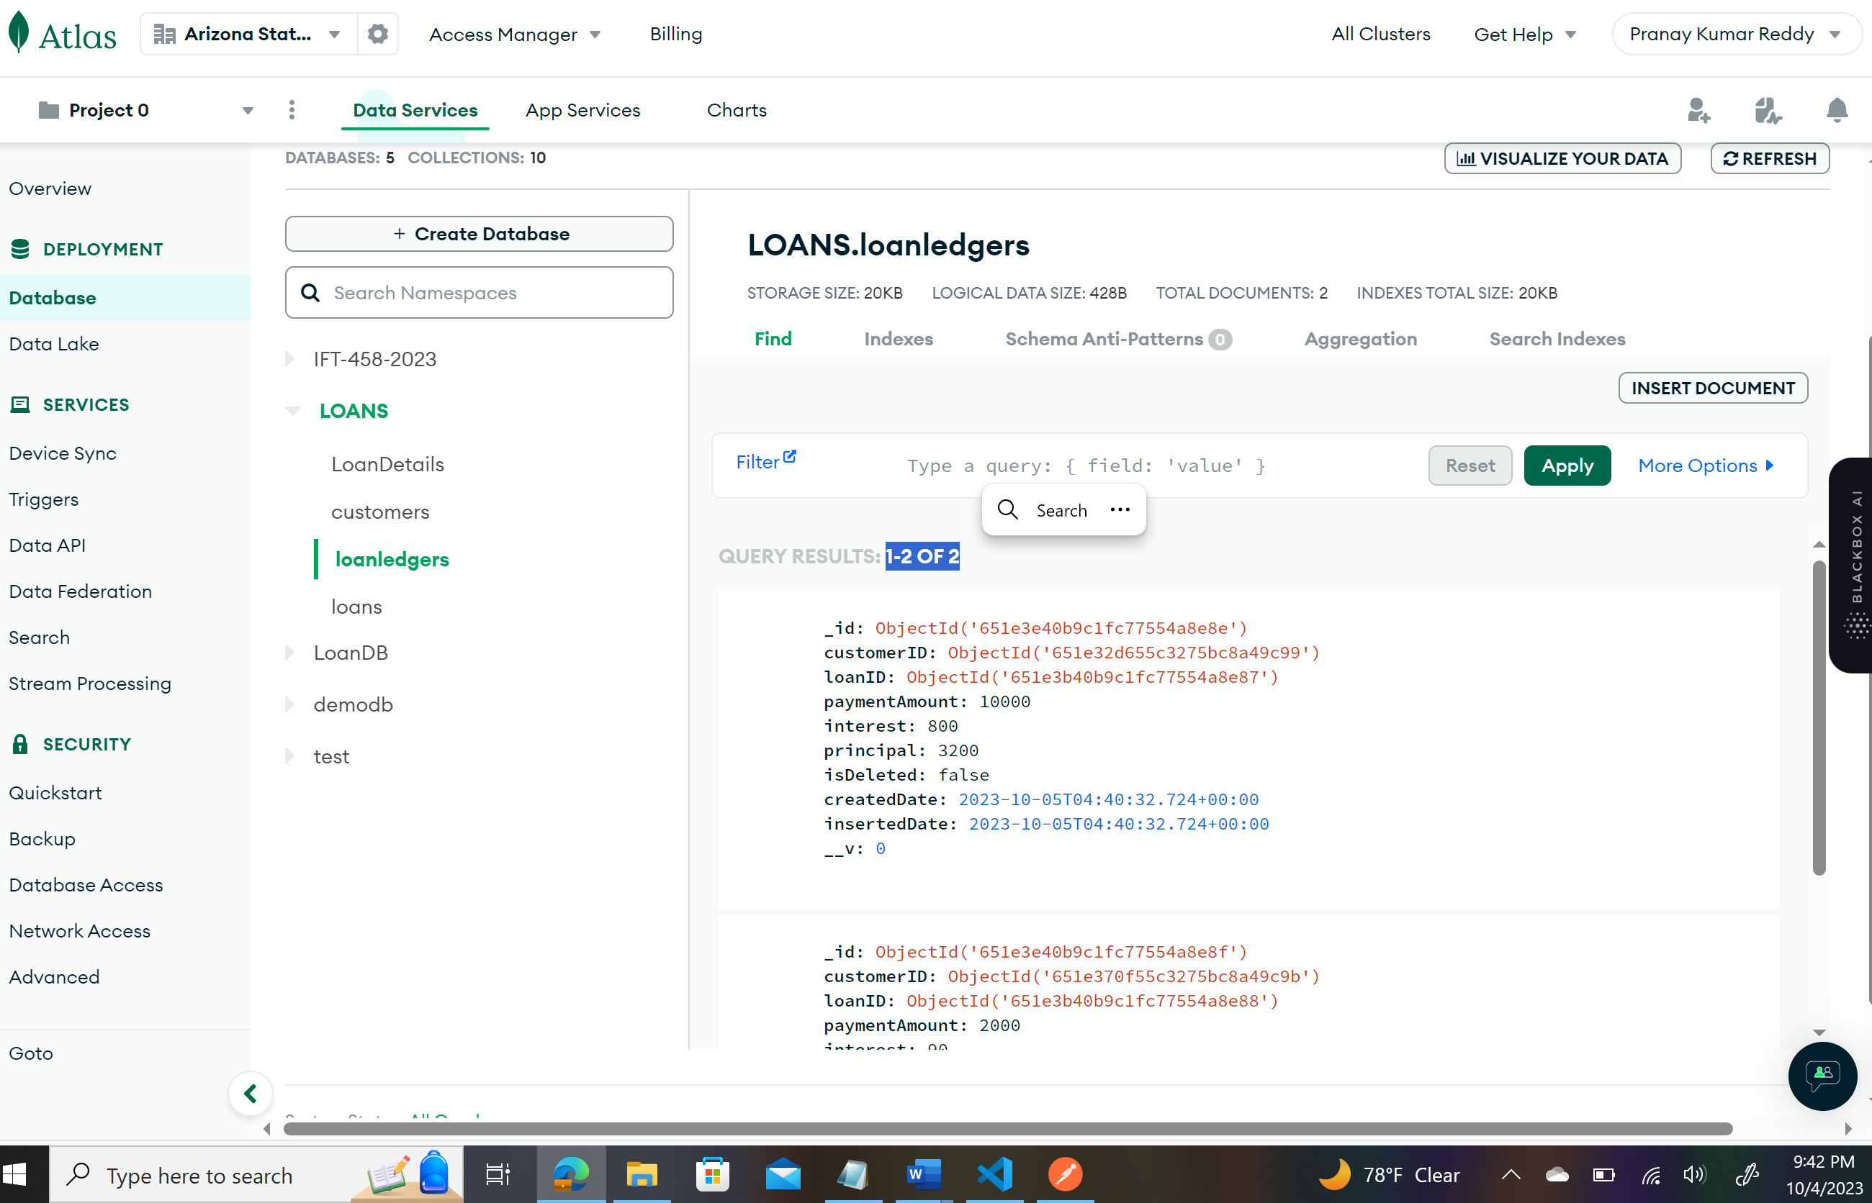

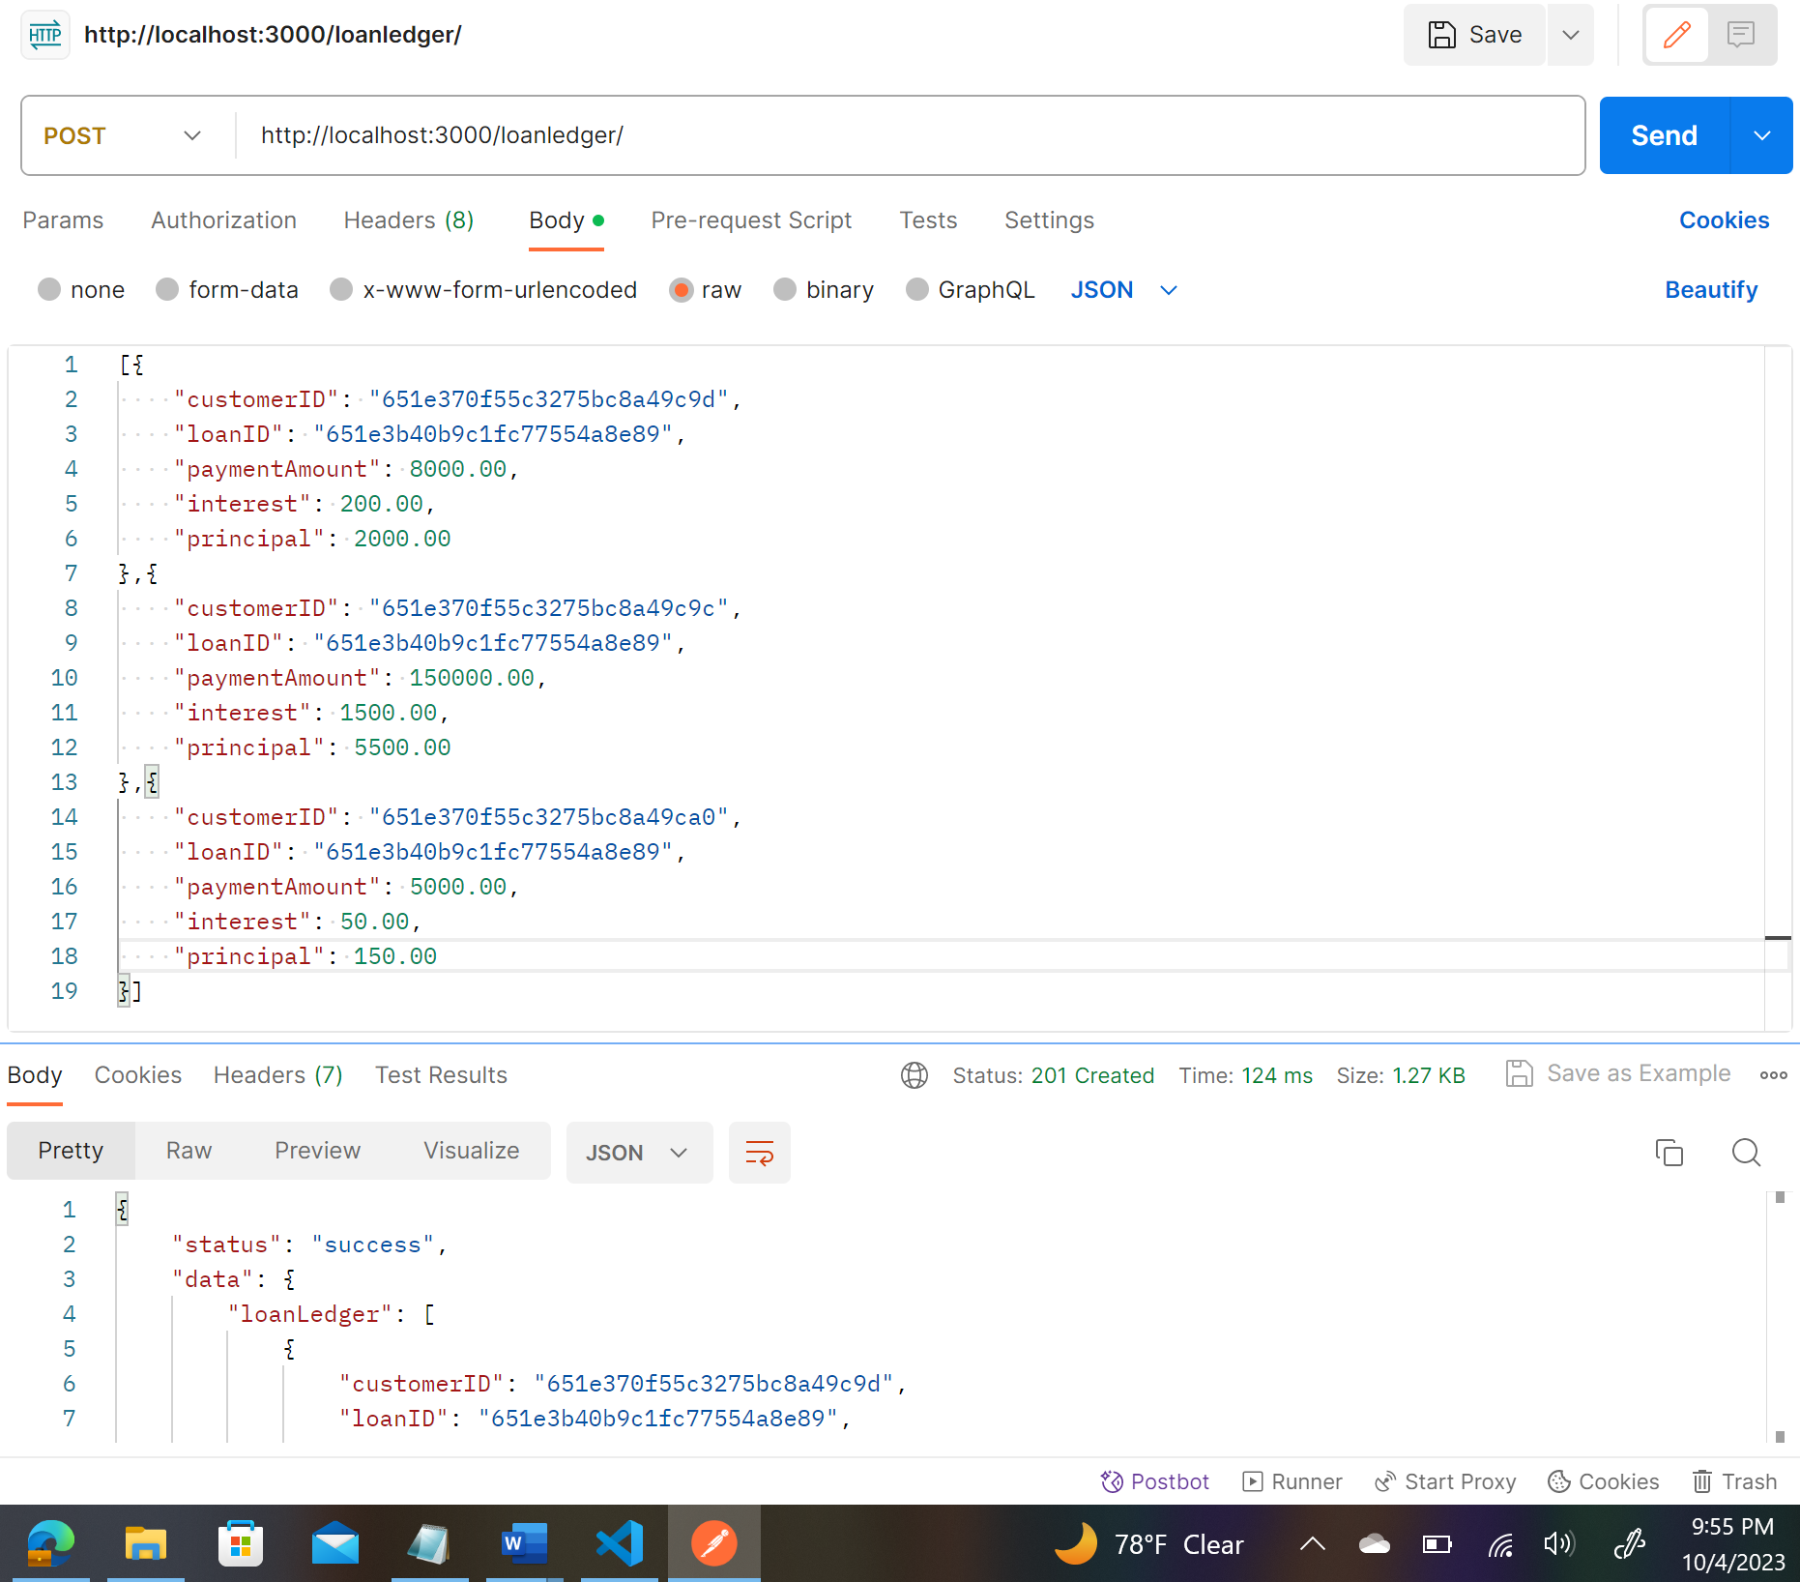

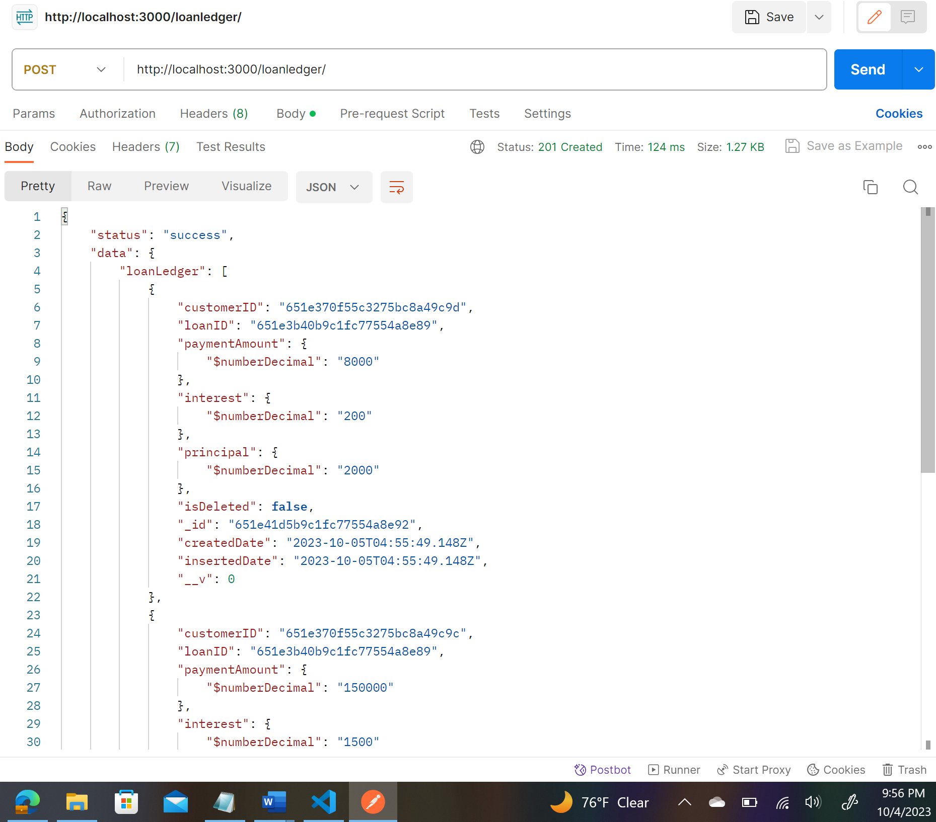

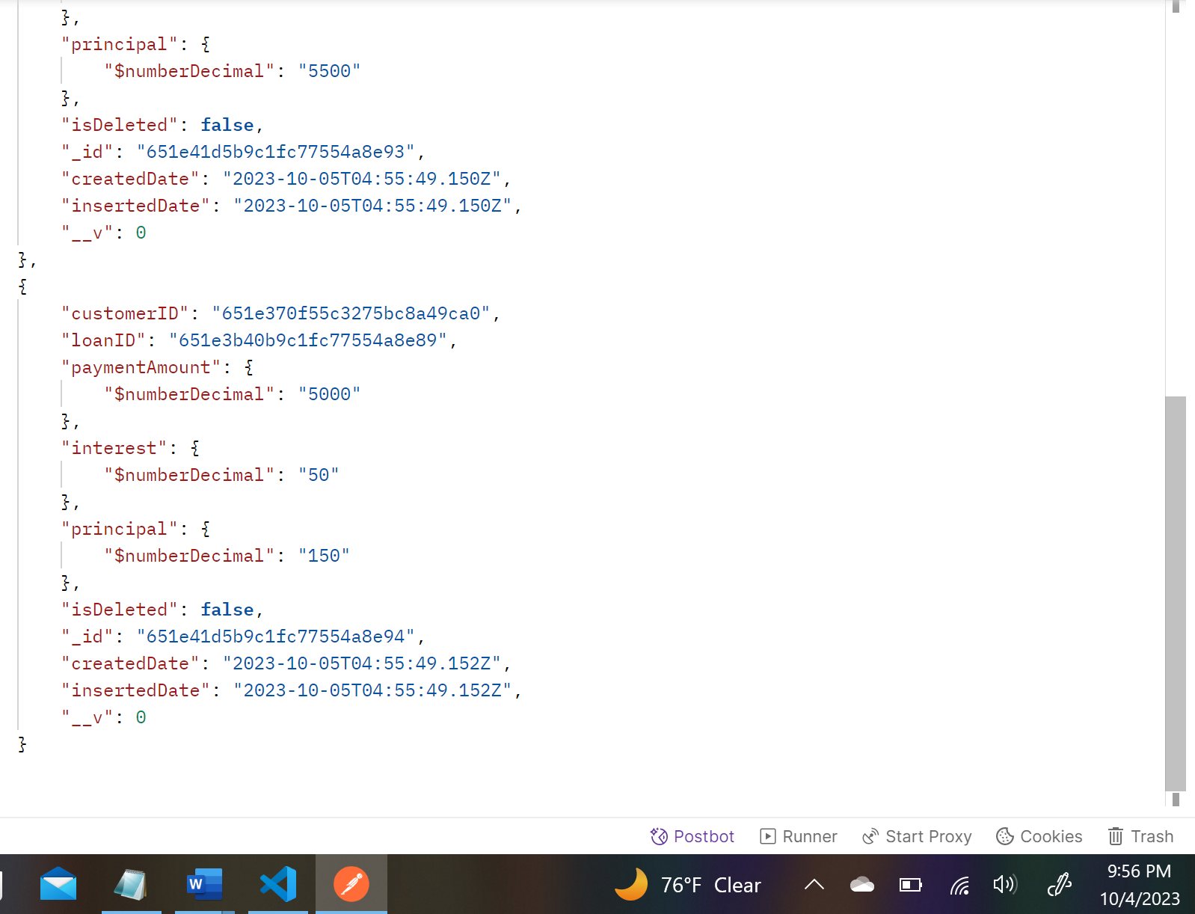

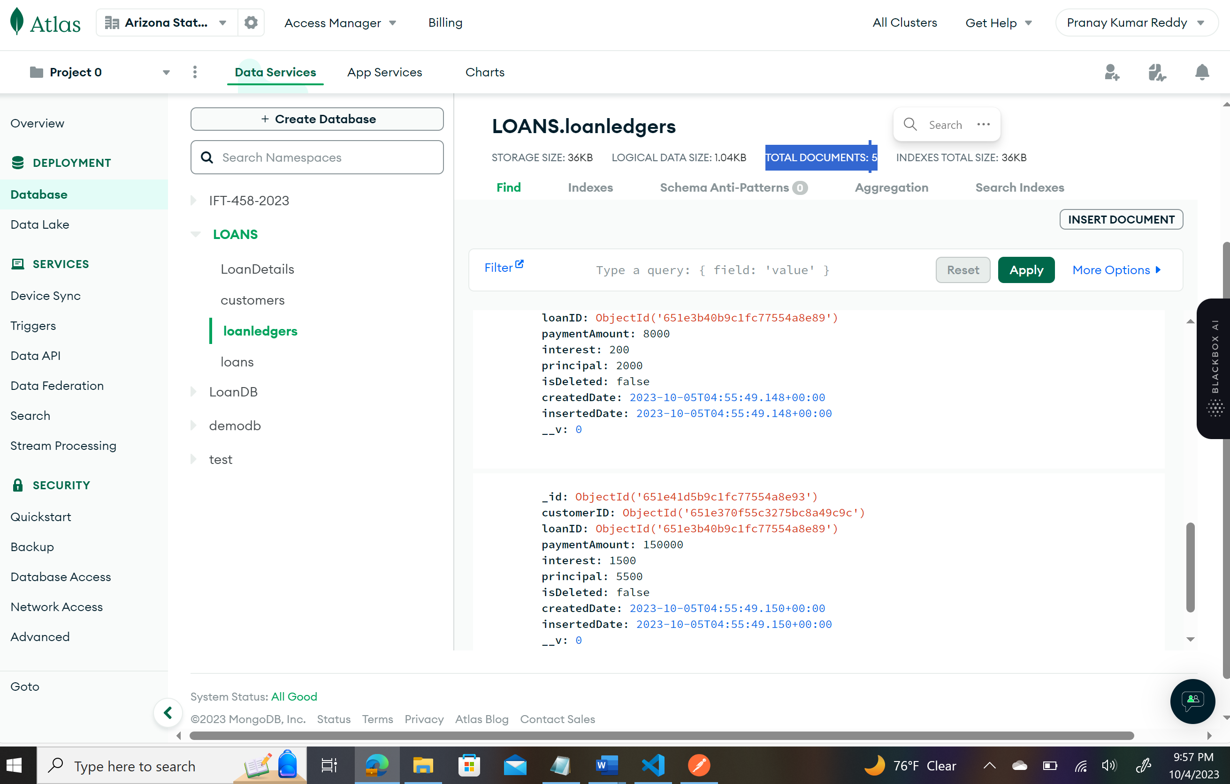

**Second Payment of 5 Customers:**

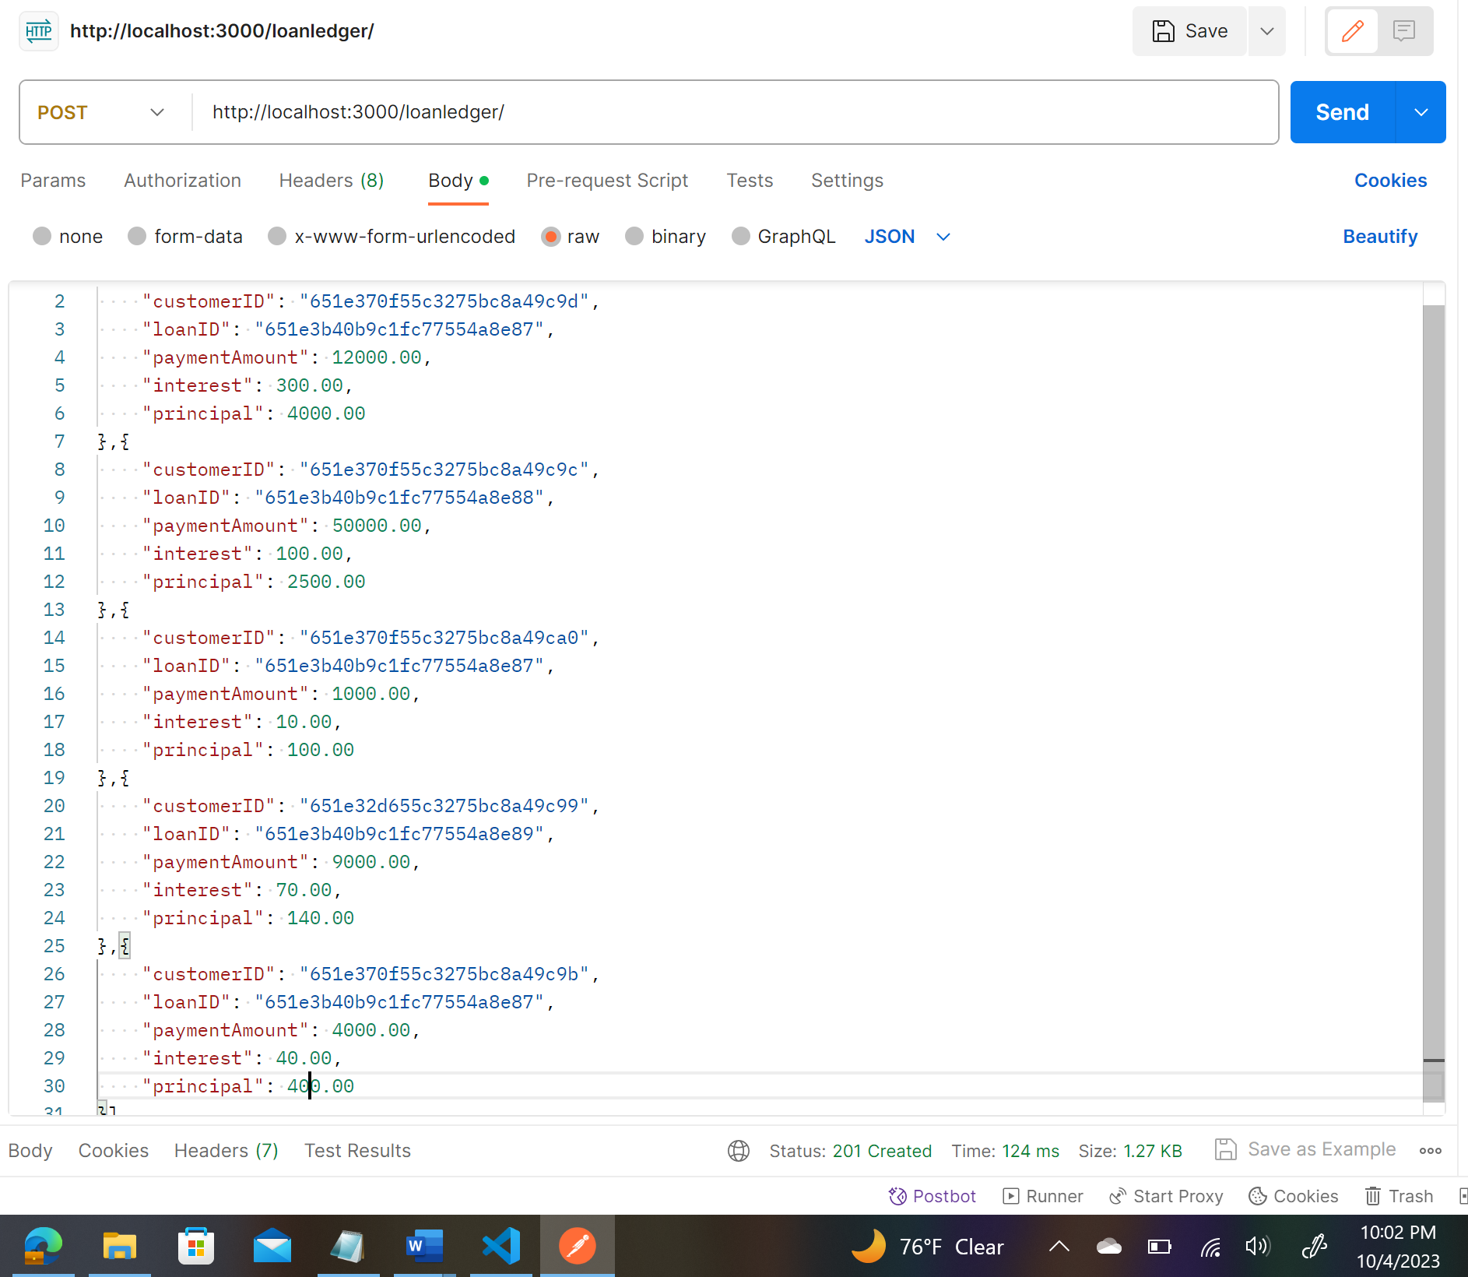

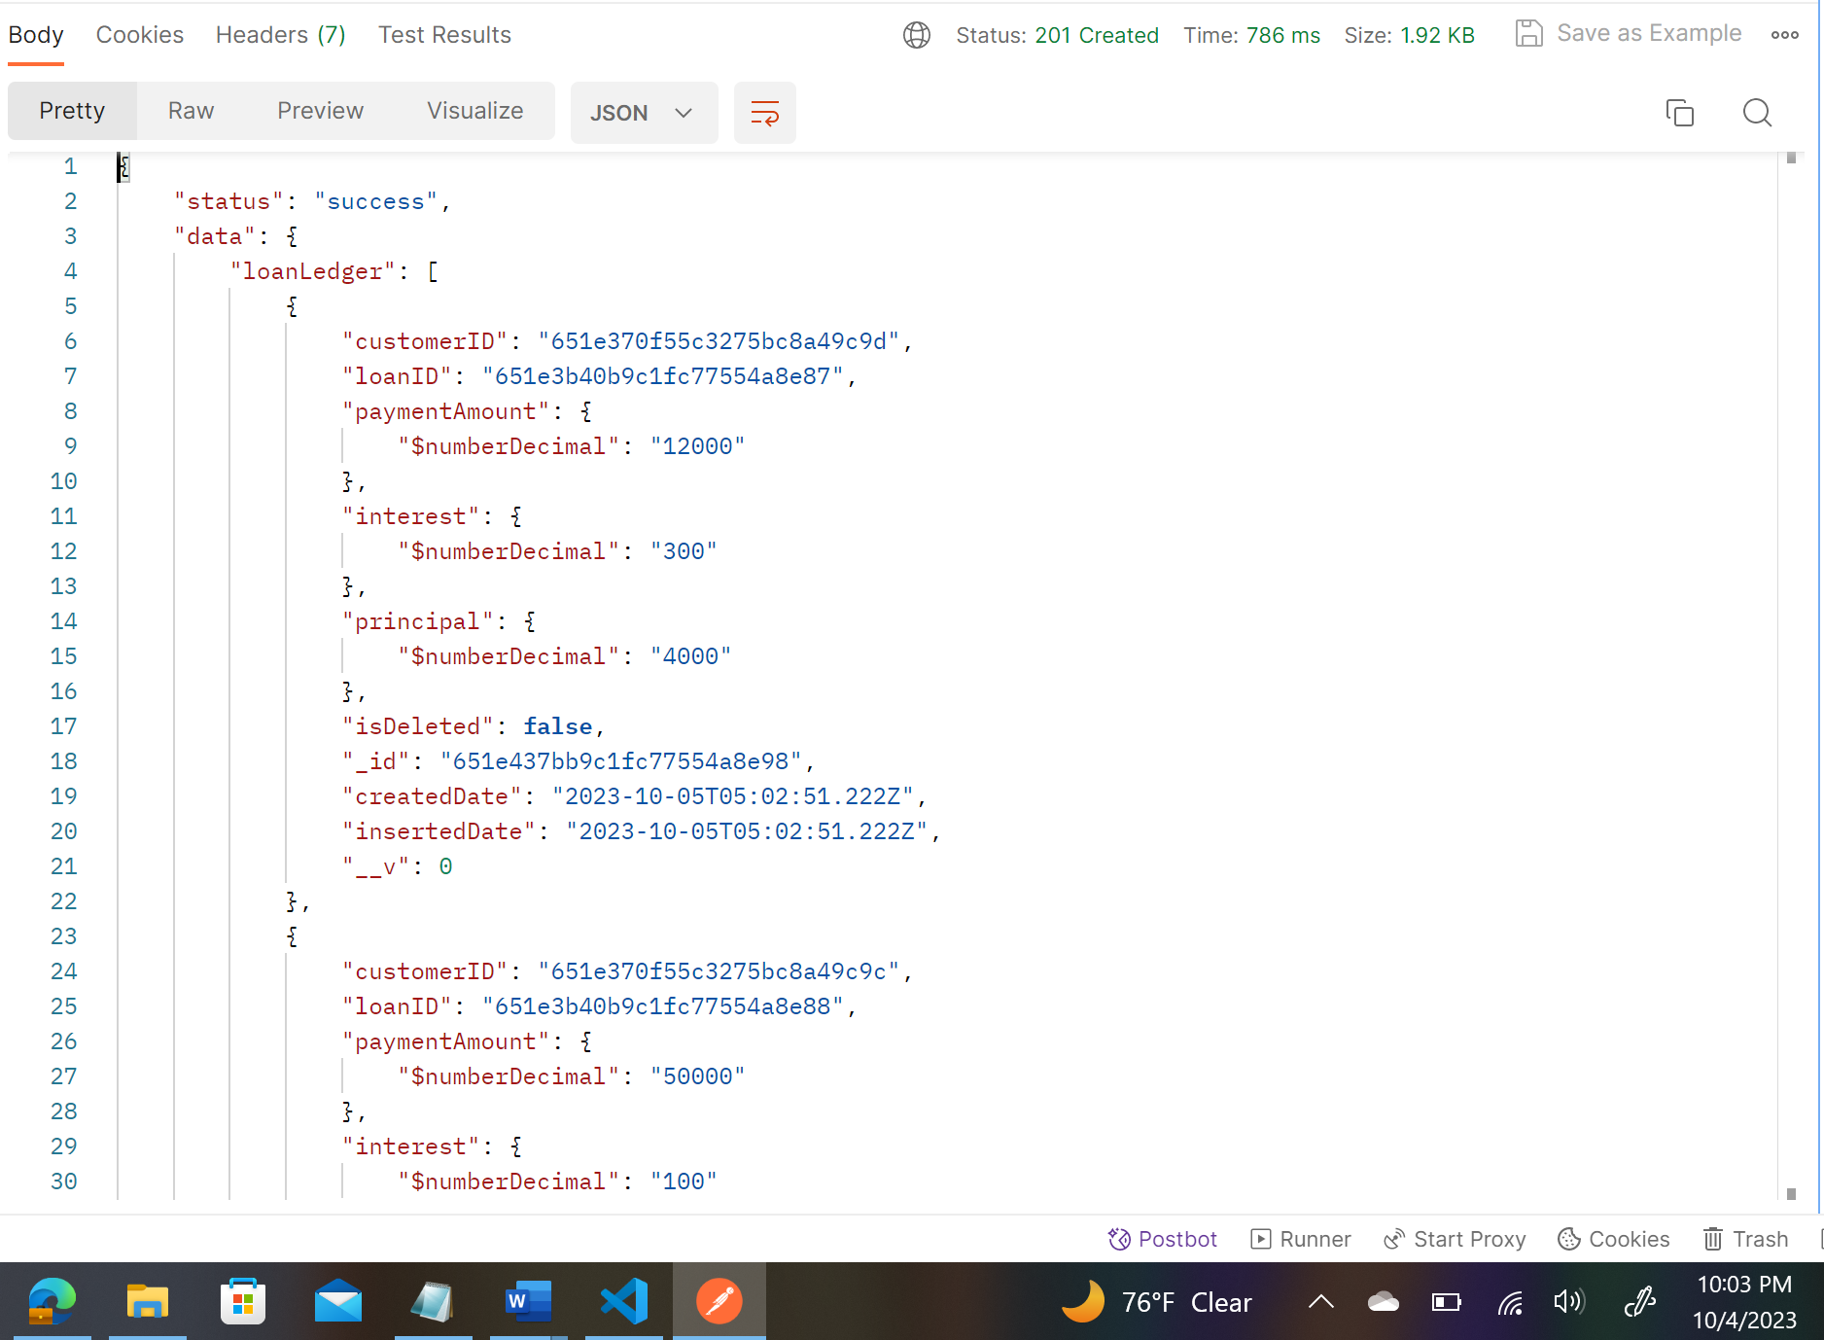

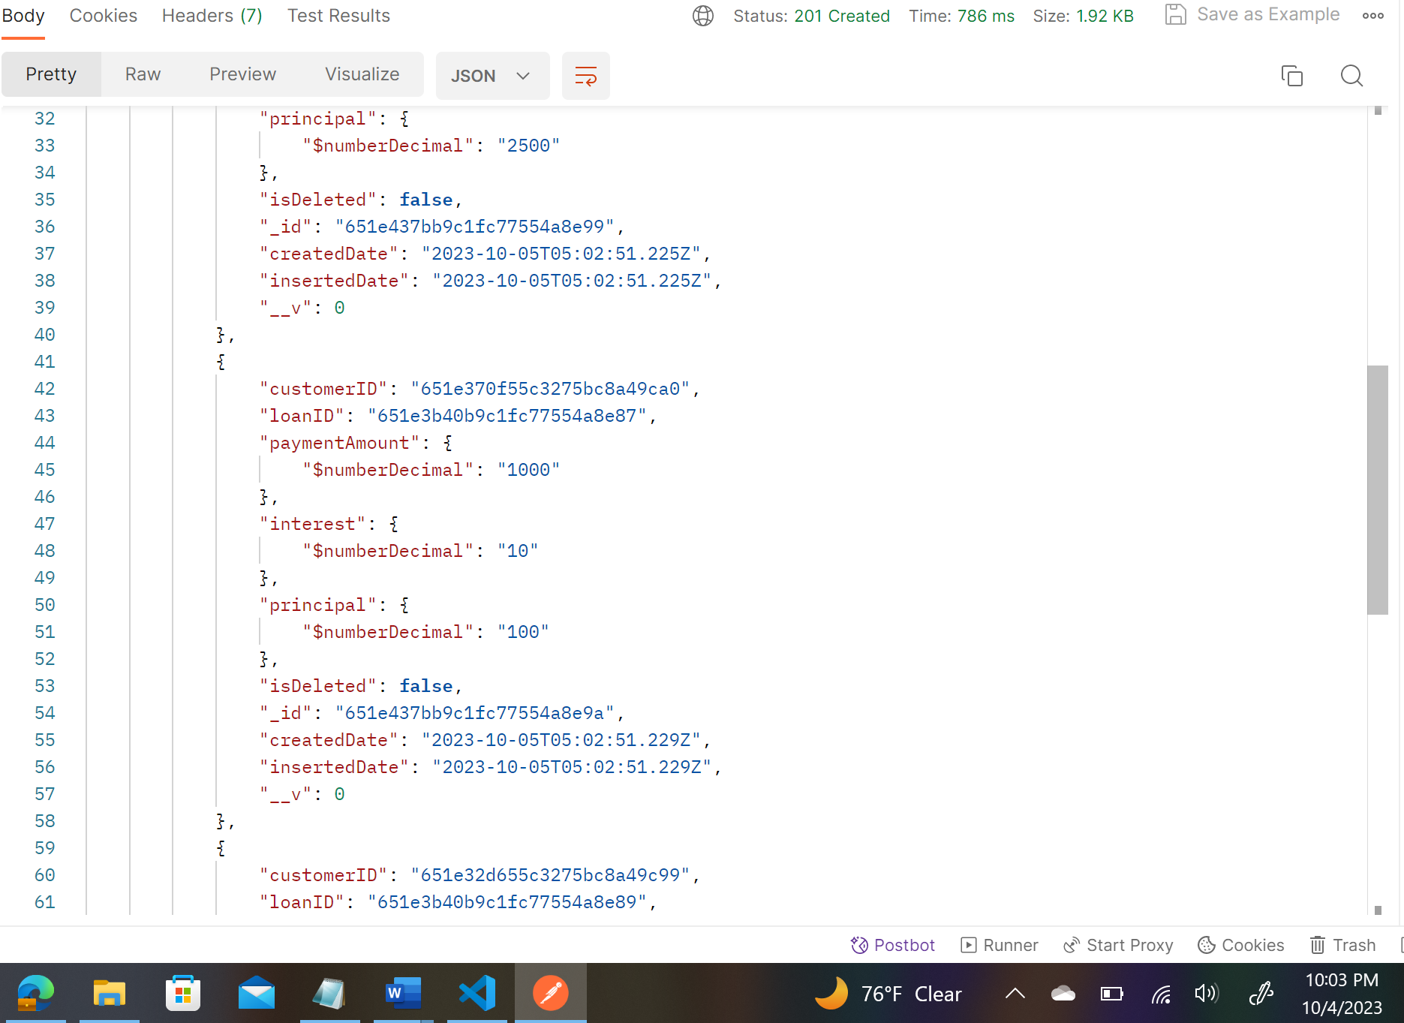

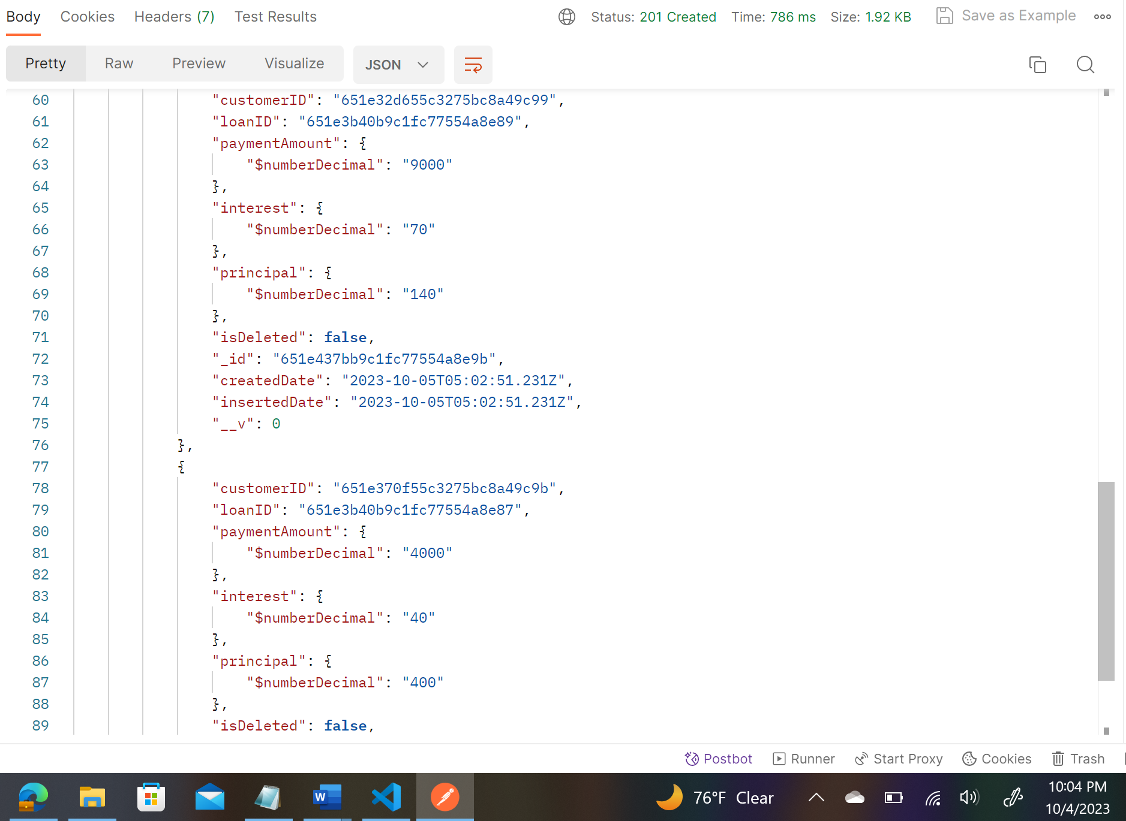

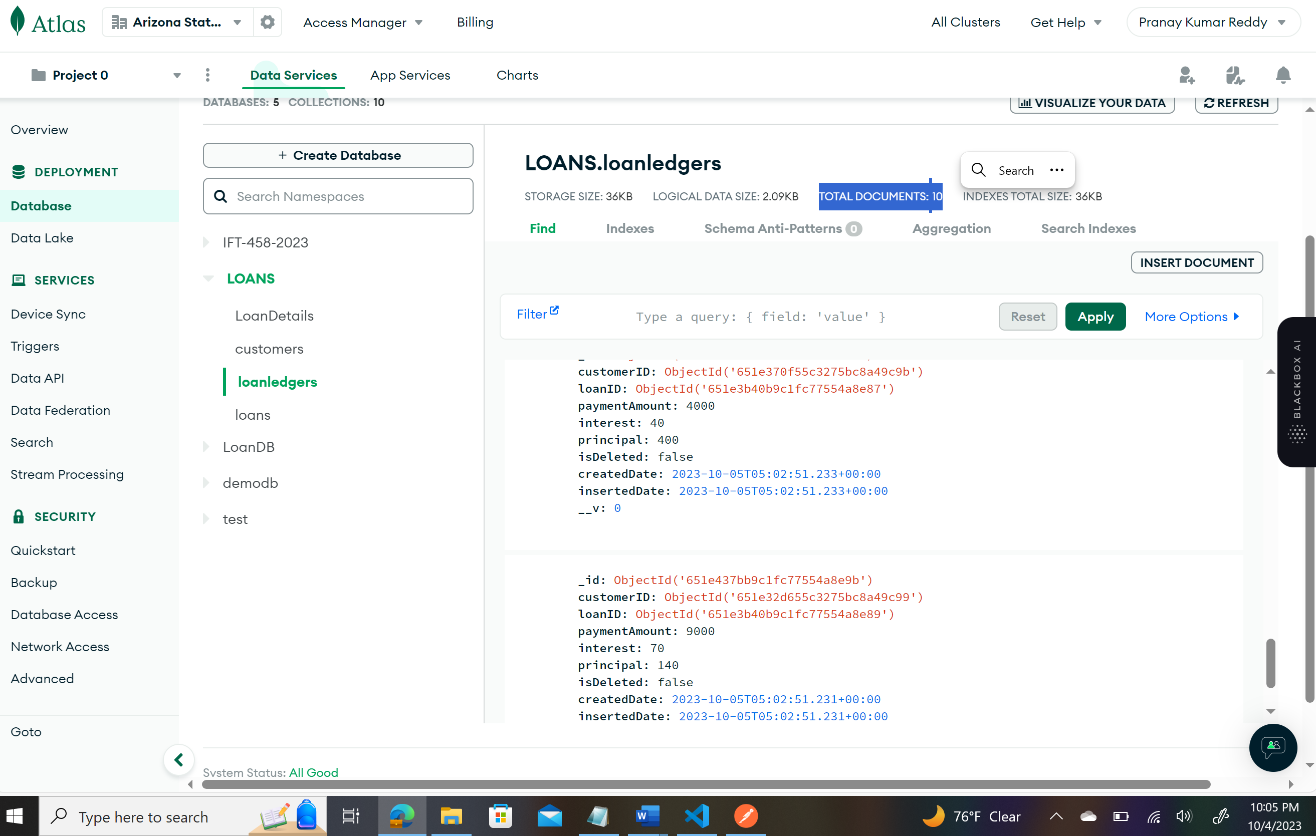

**Part 3: Requirement Storage Design Implementation:**

**Part 4: Use POSTMAN as a client application to test your App server and the Middleware**

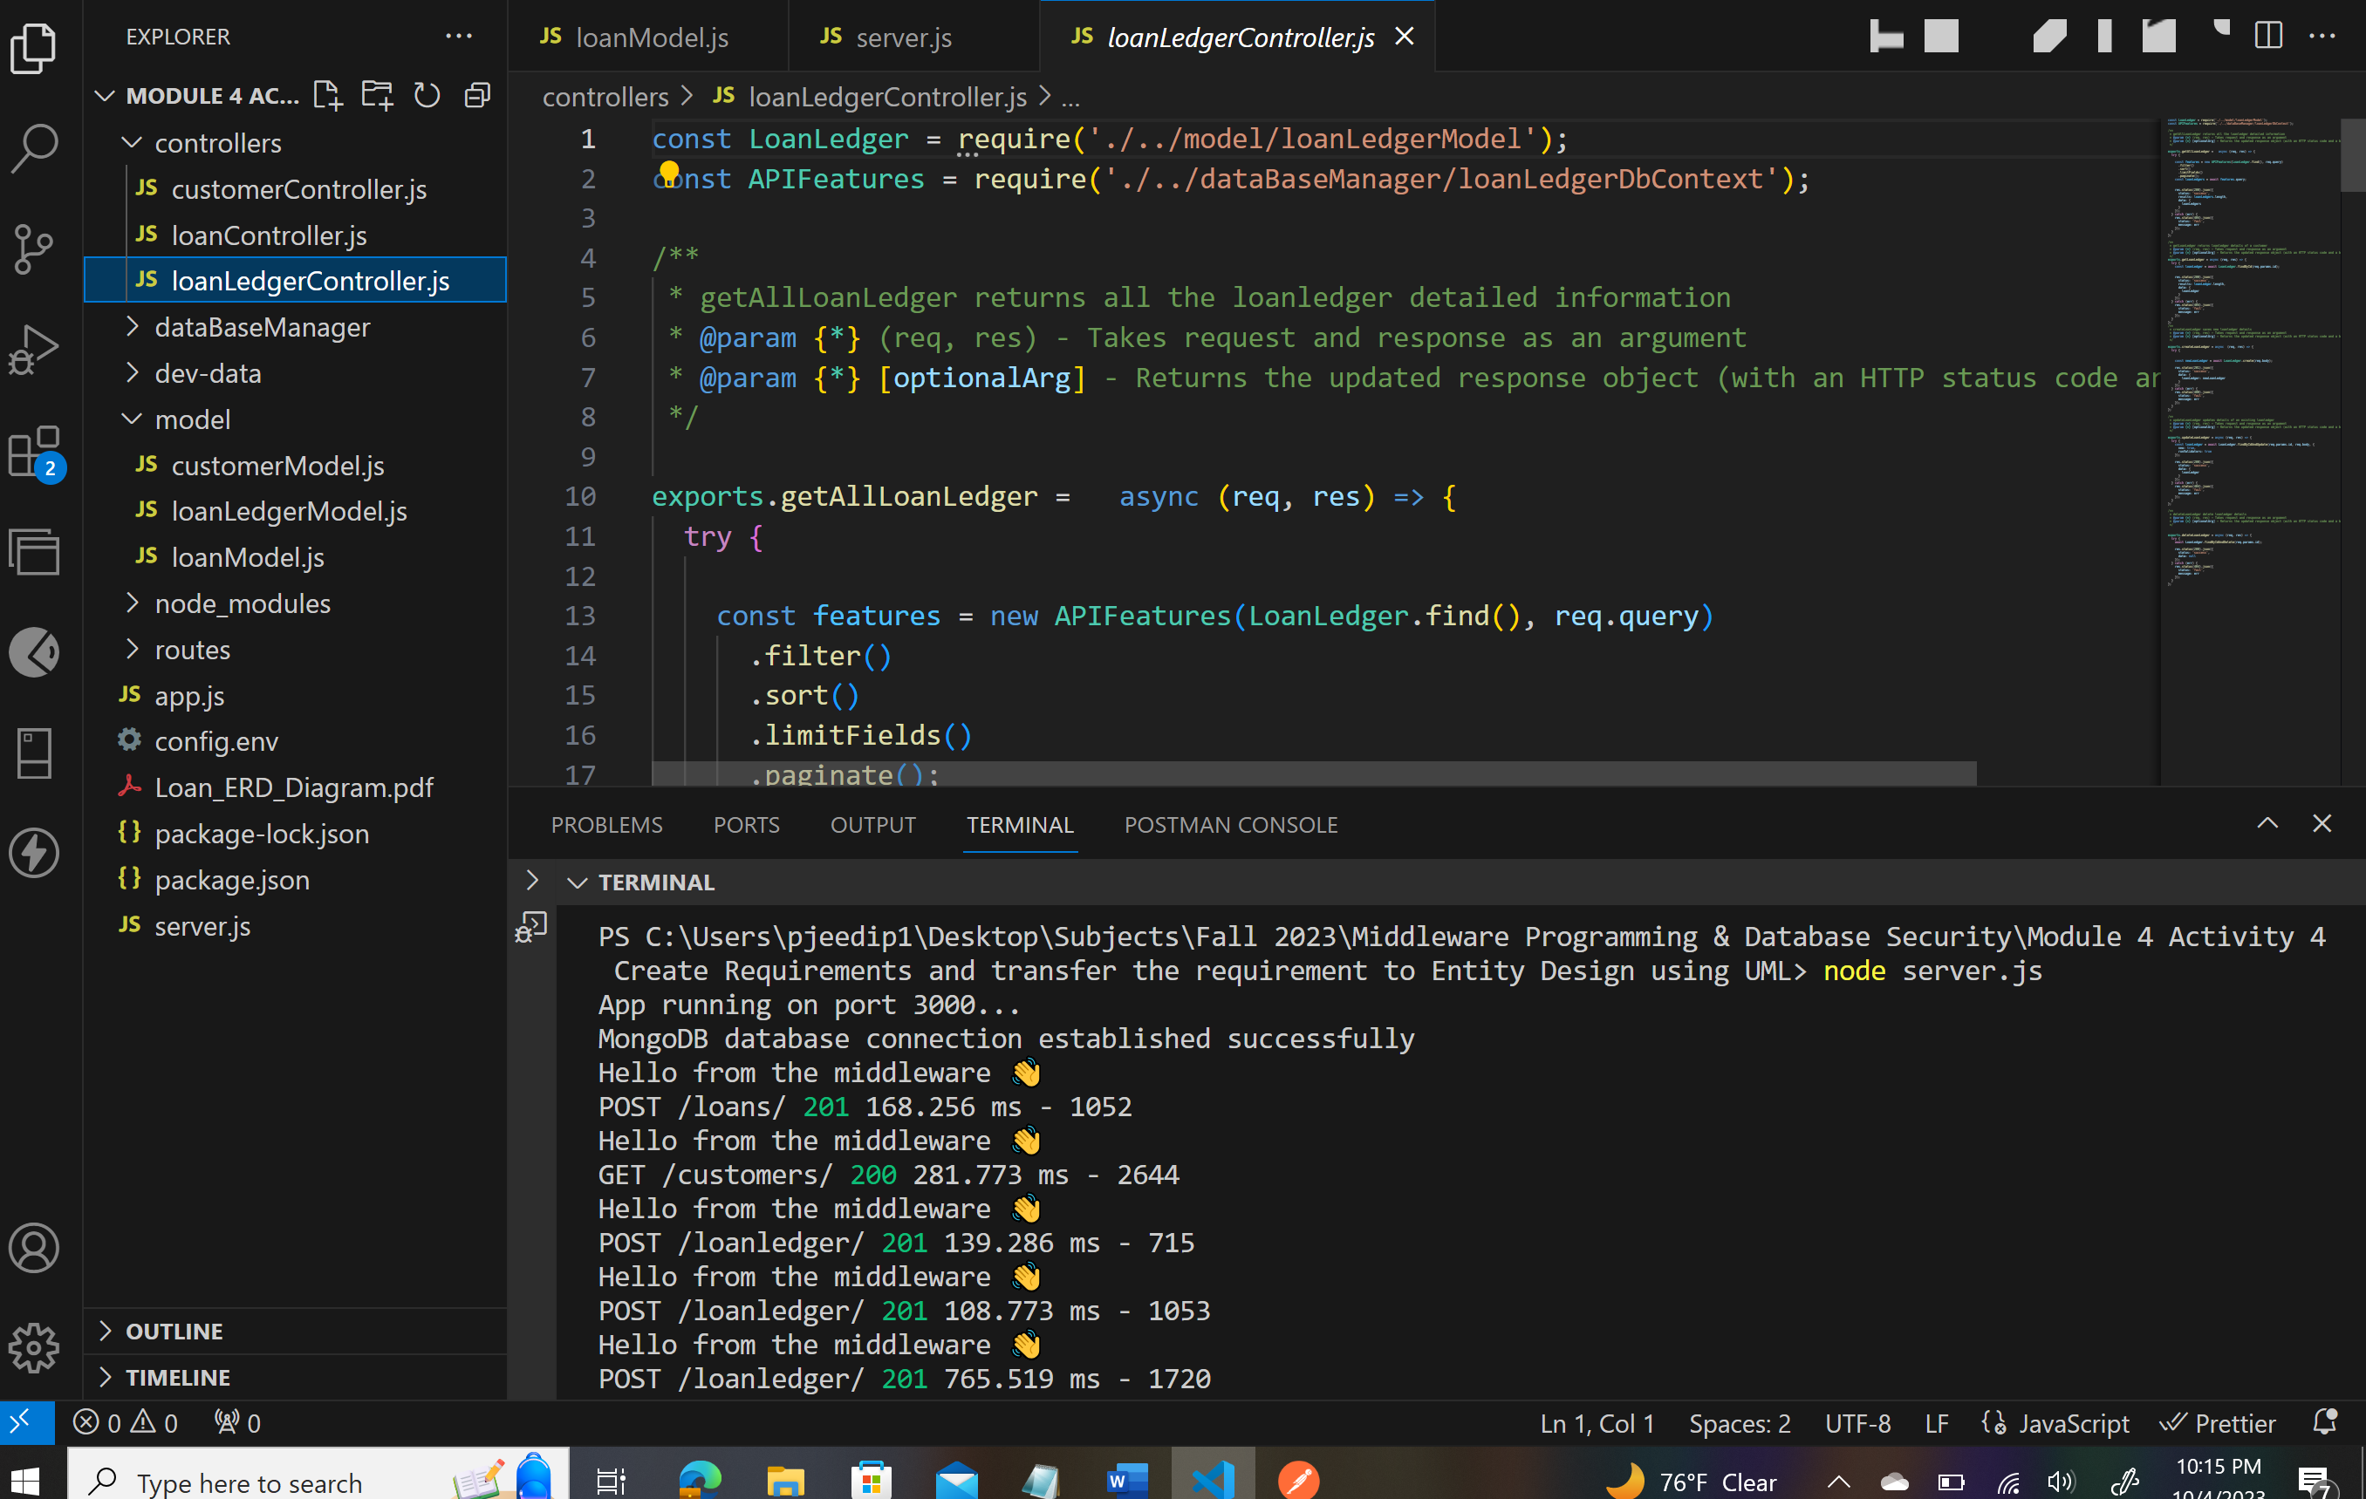

SELECT ( Get):

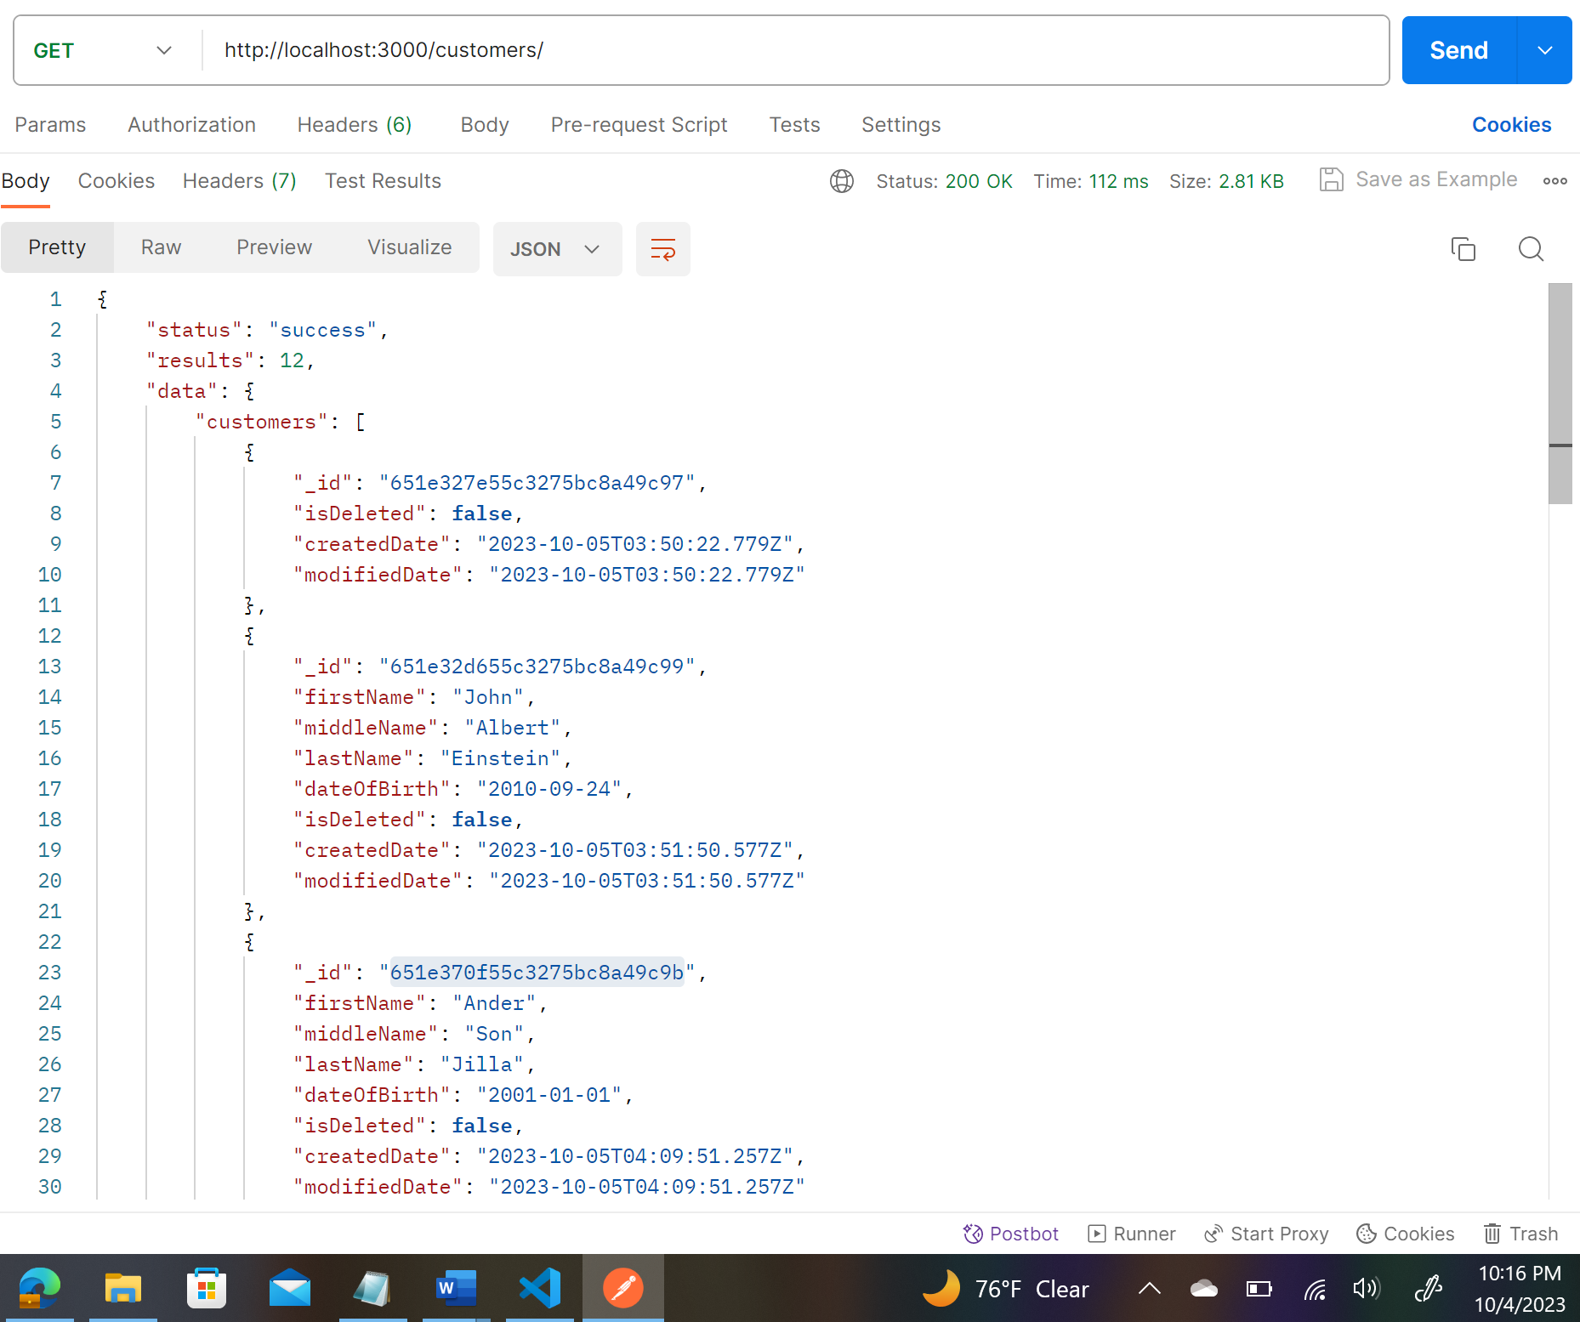

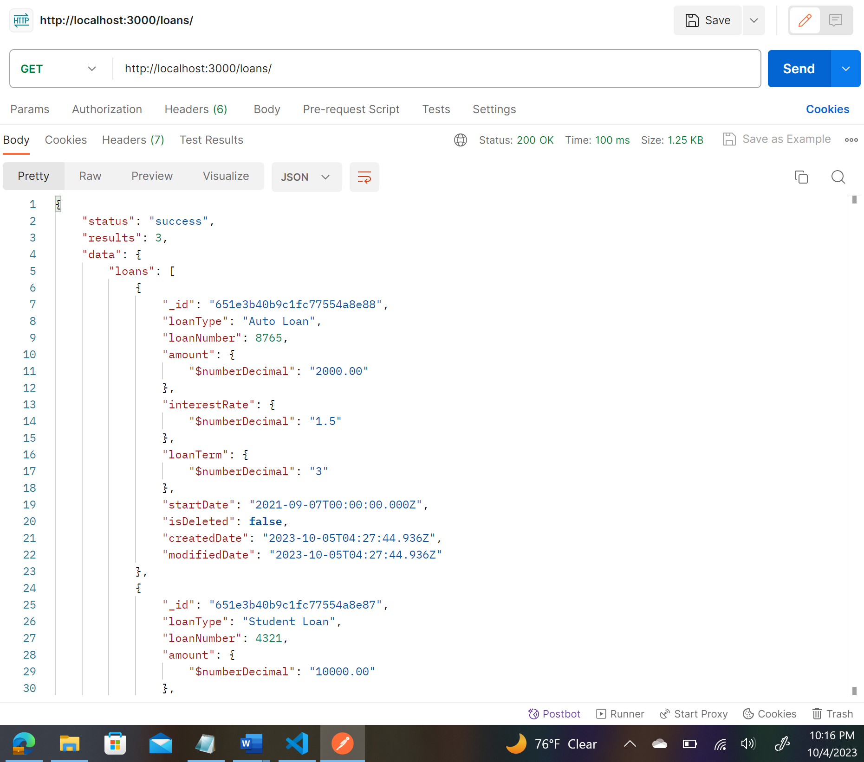

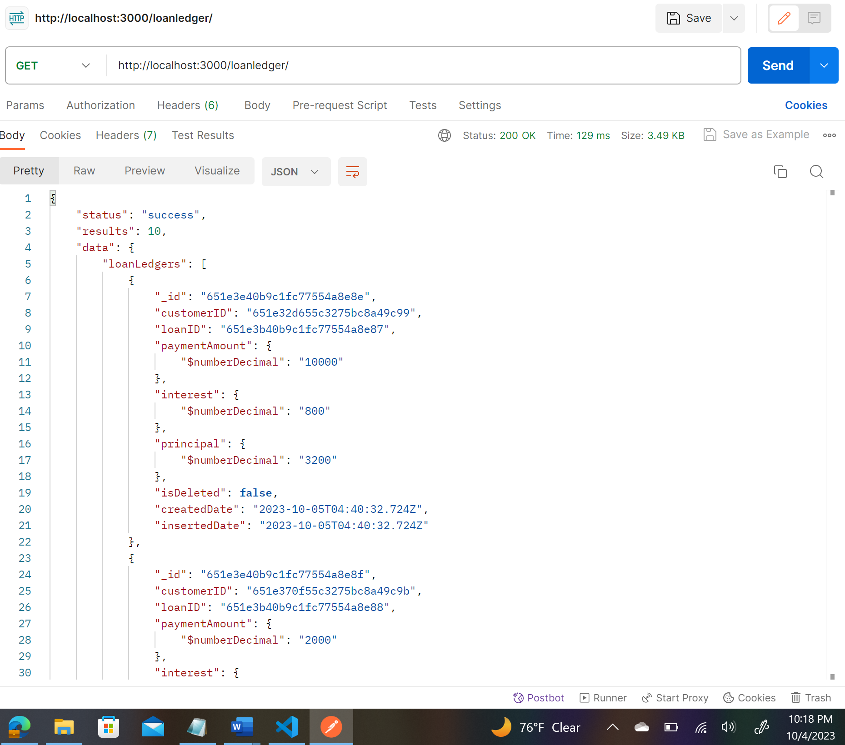INSERT( Post):

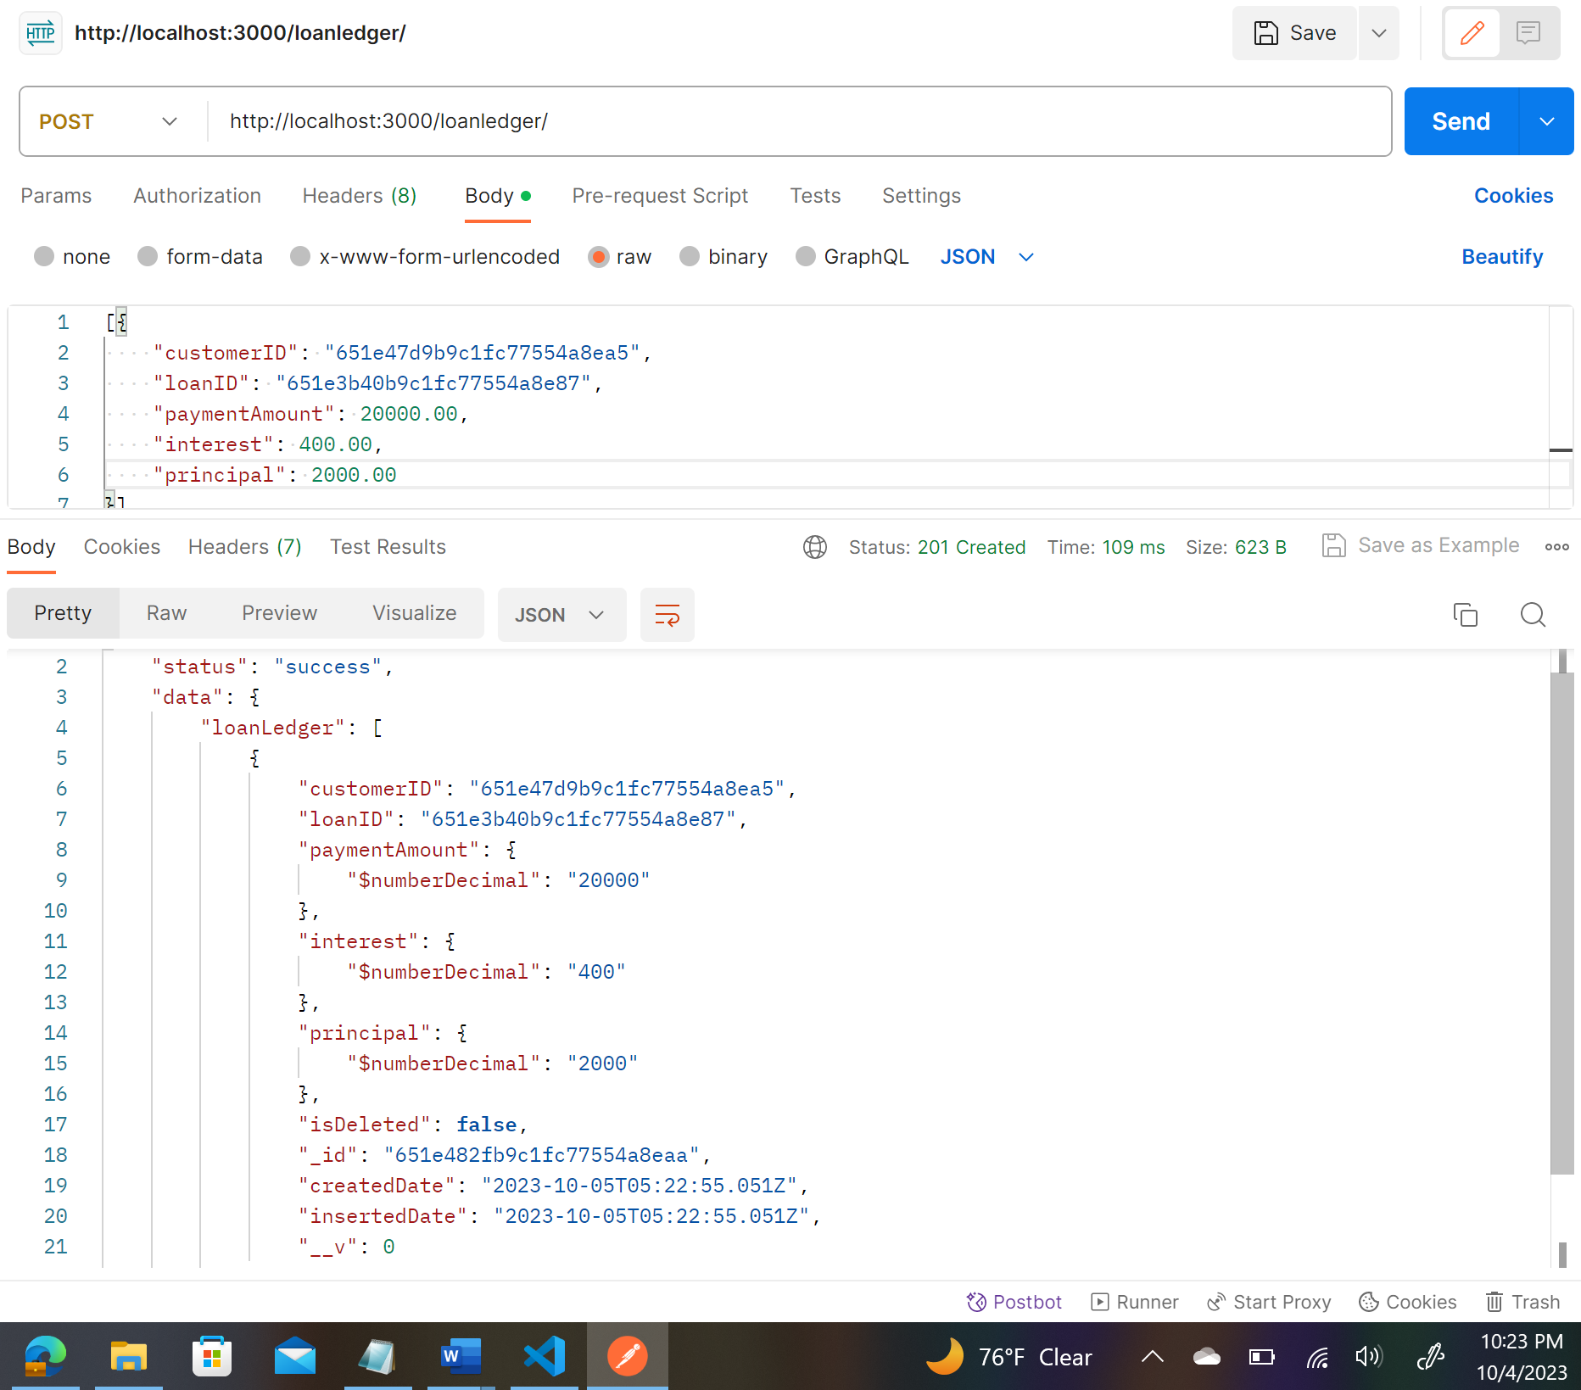

UPDATE (Put):

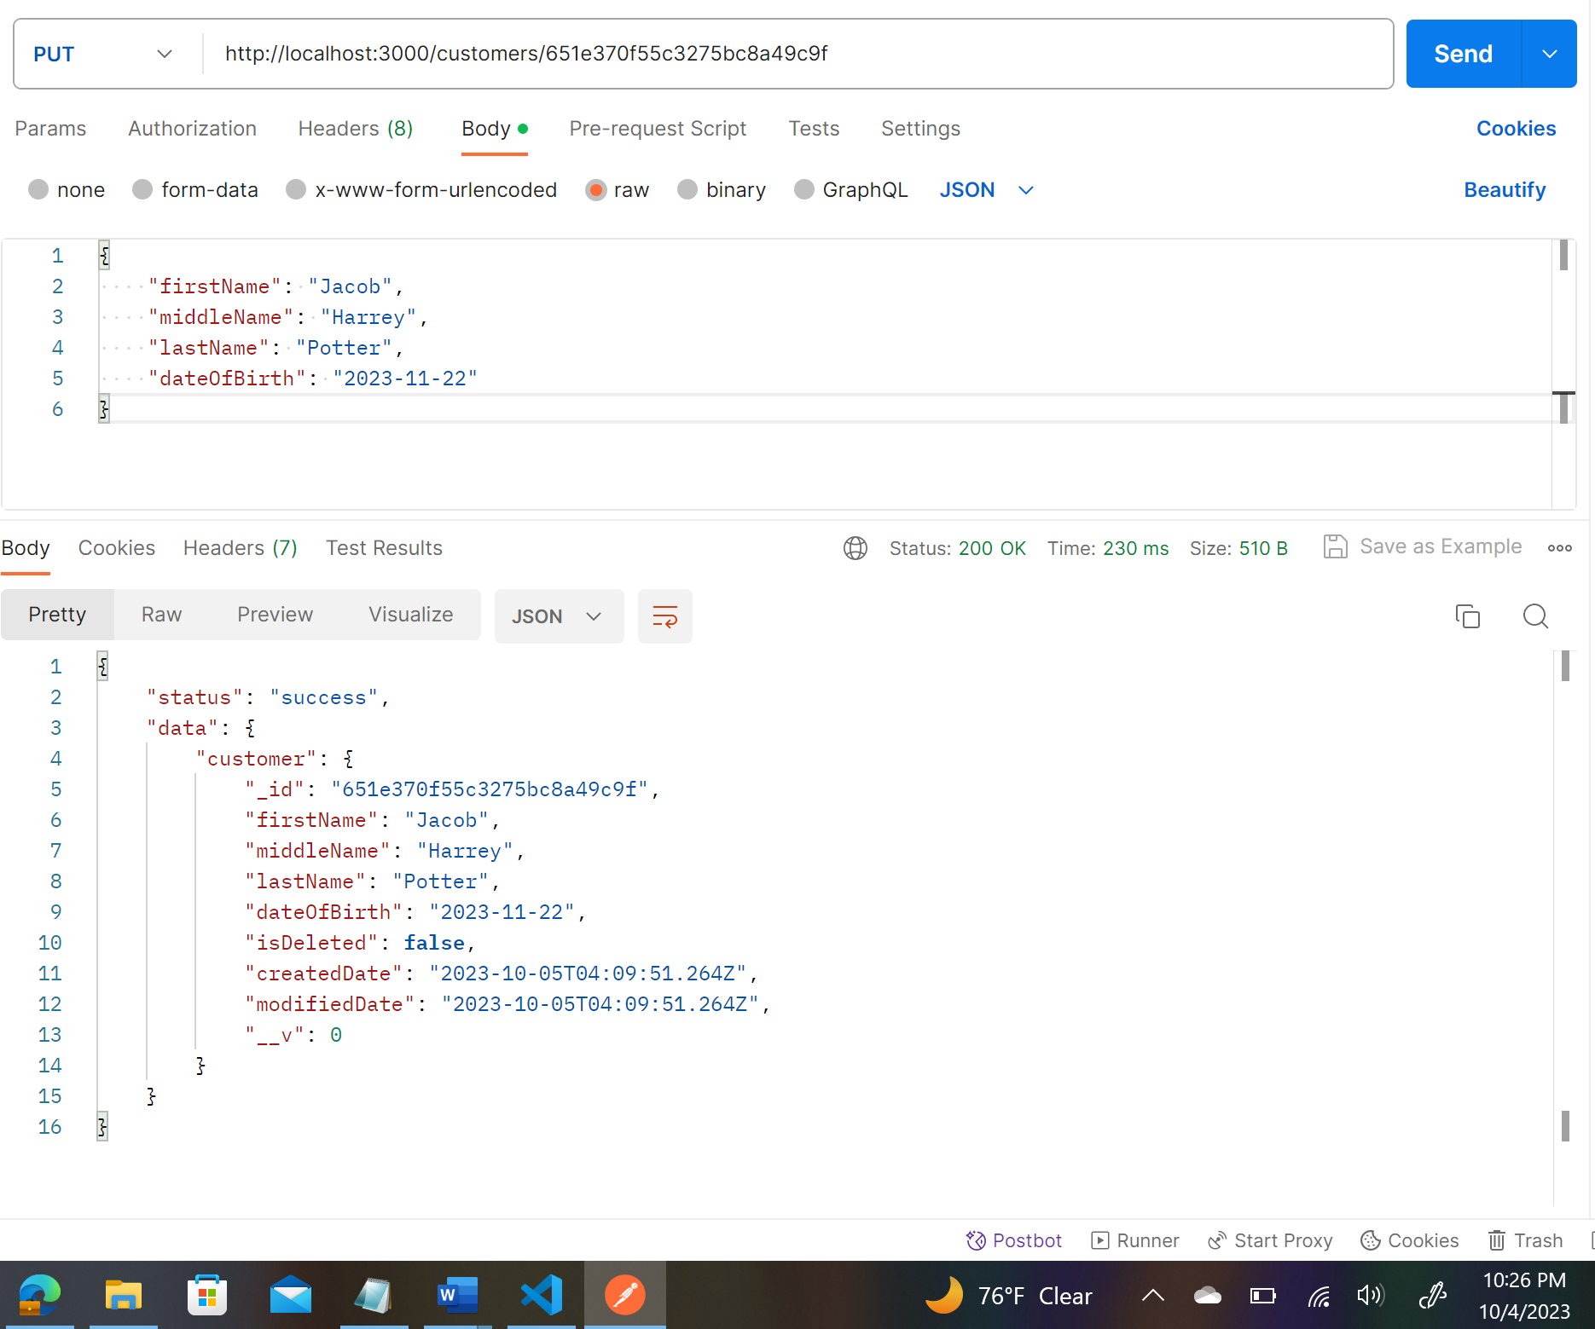

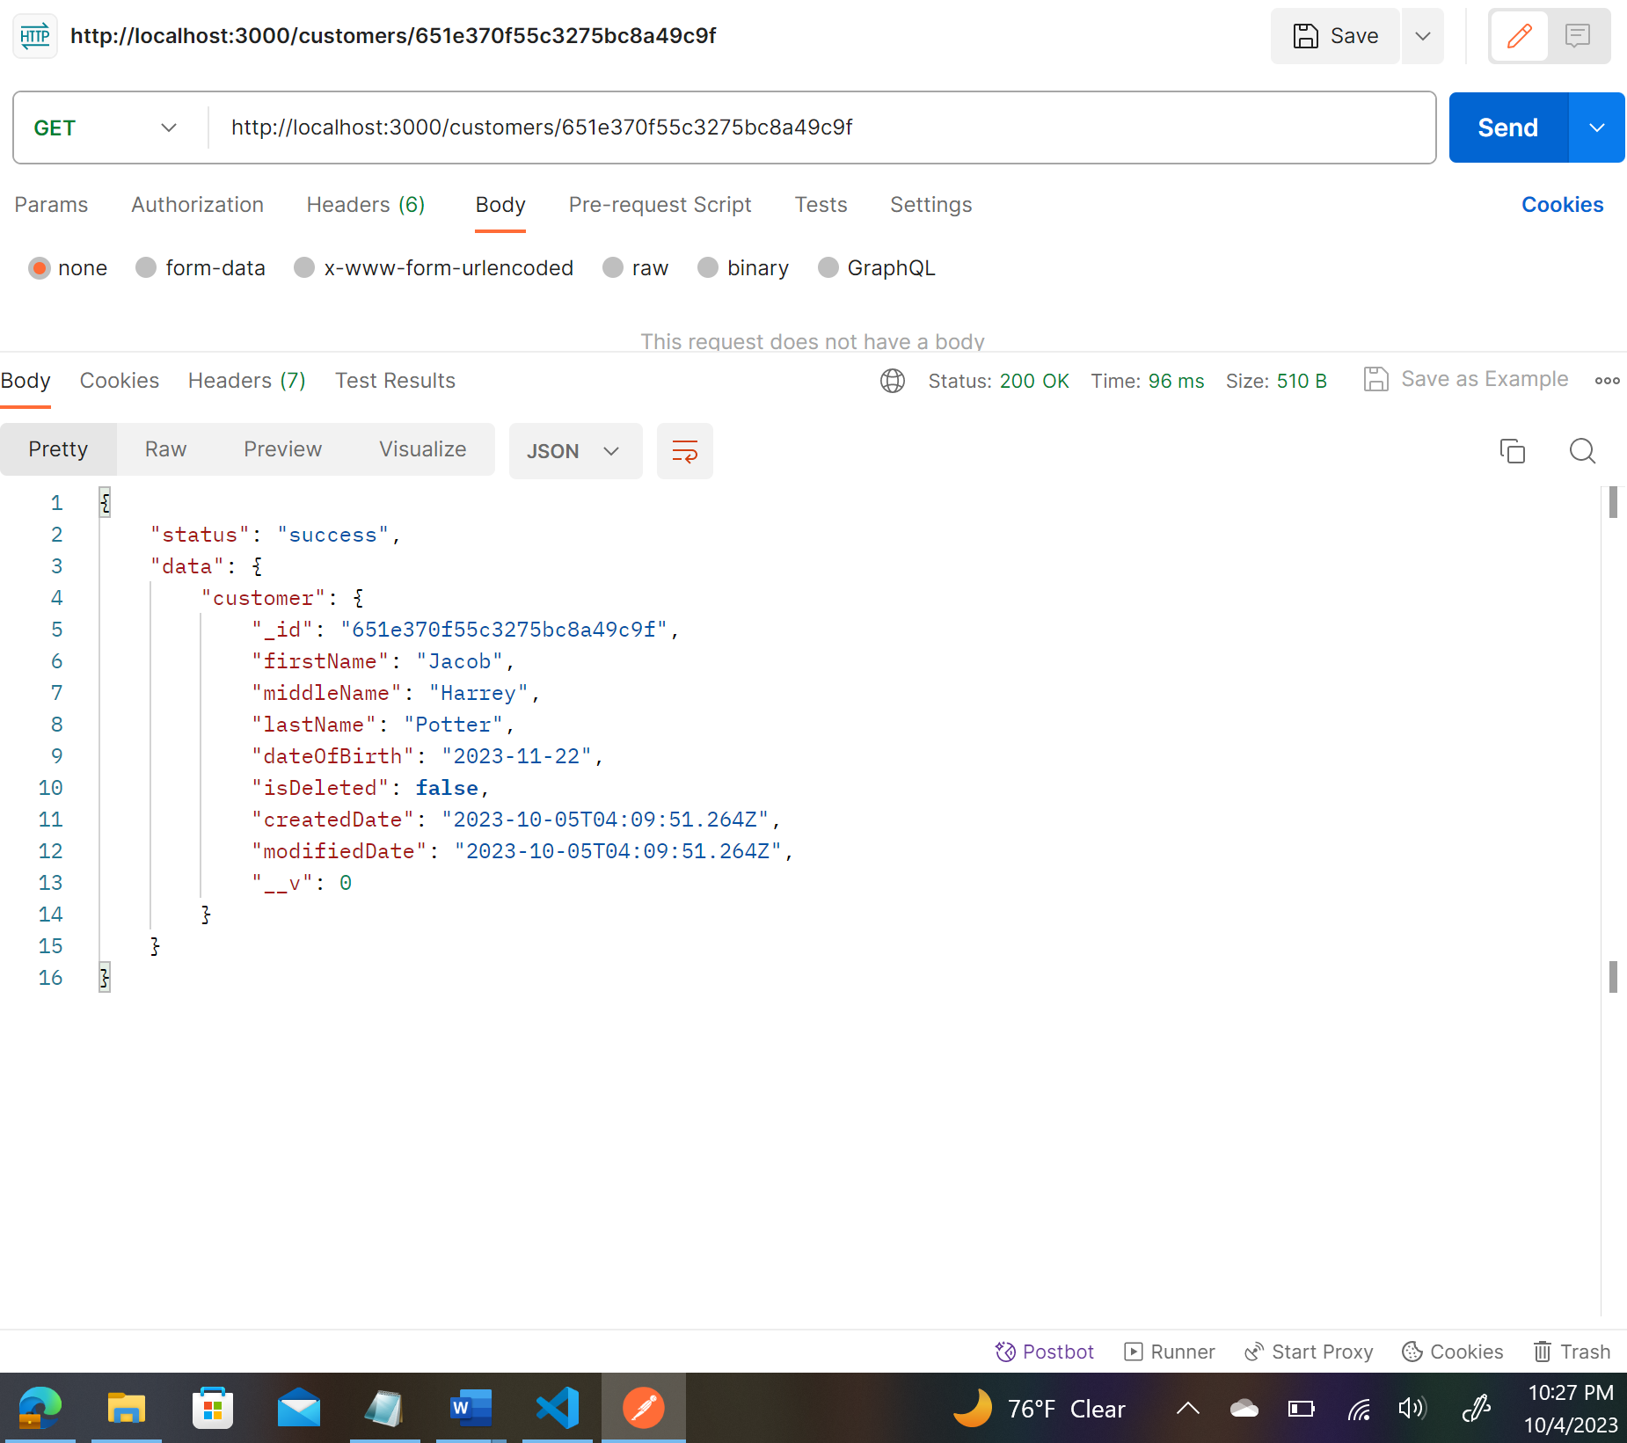

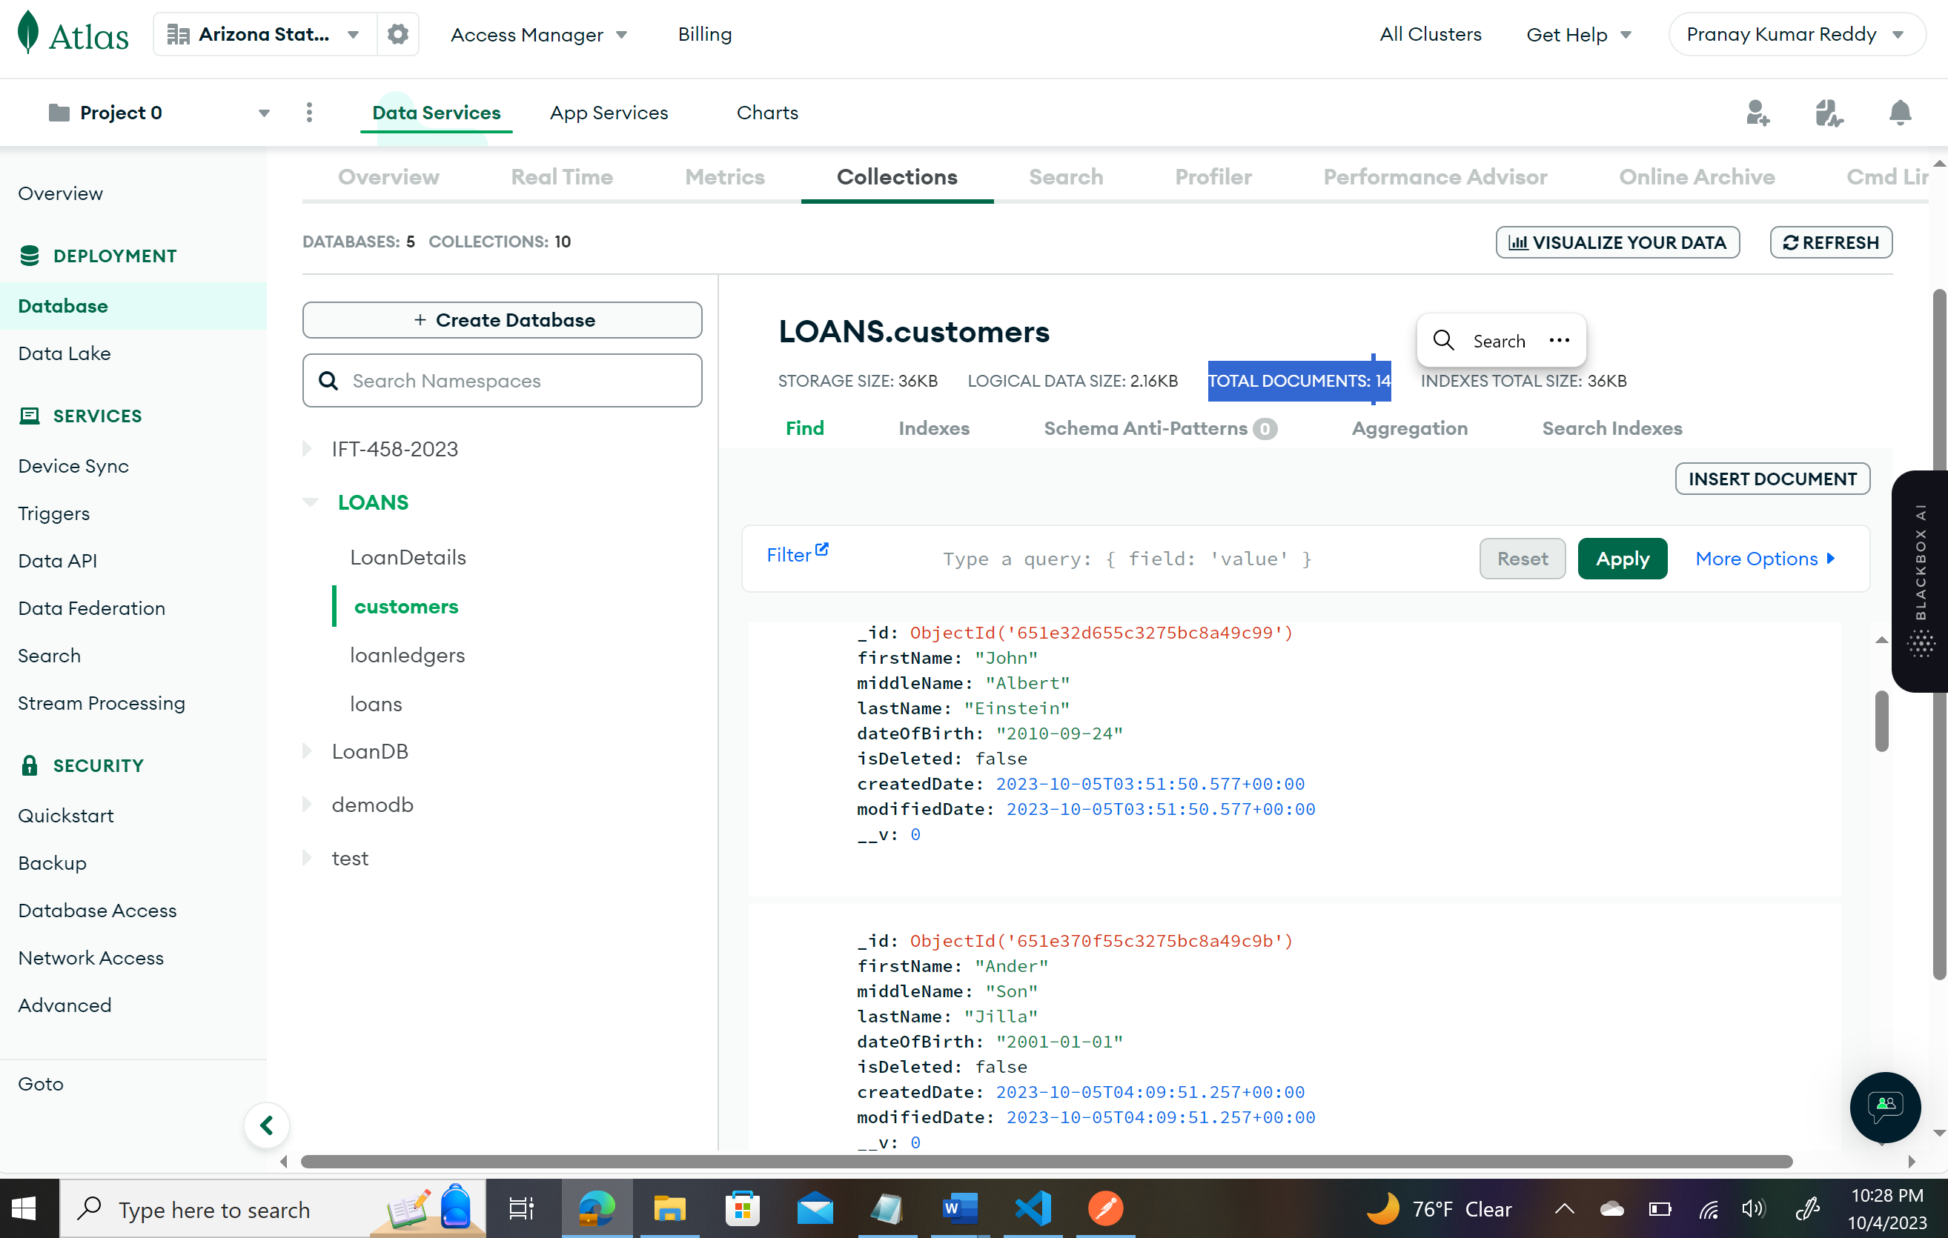

DELETE (Delete):

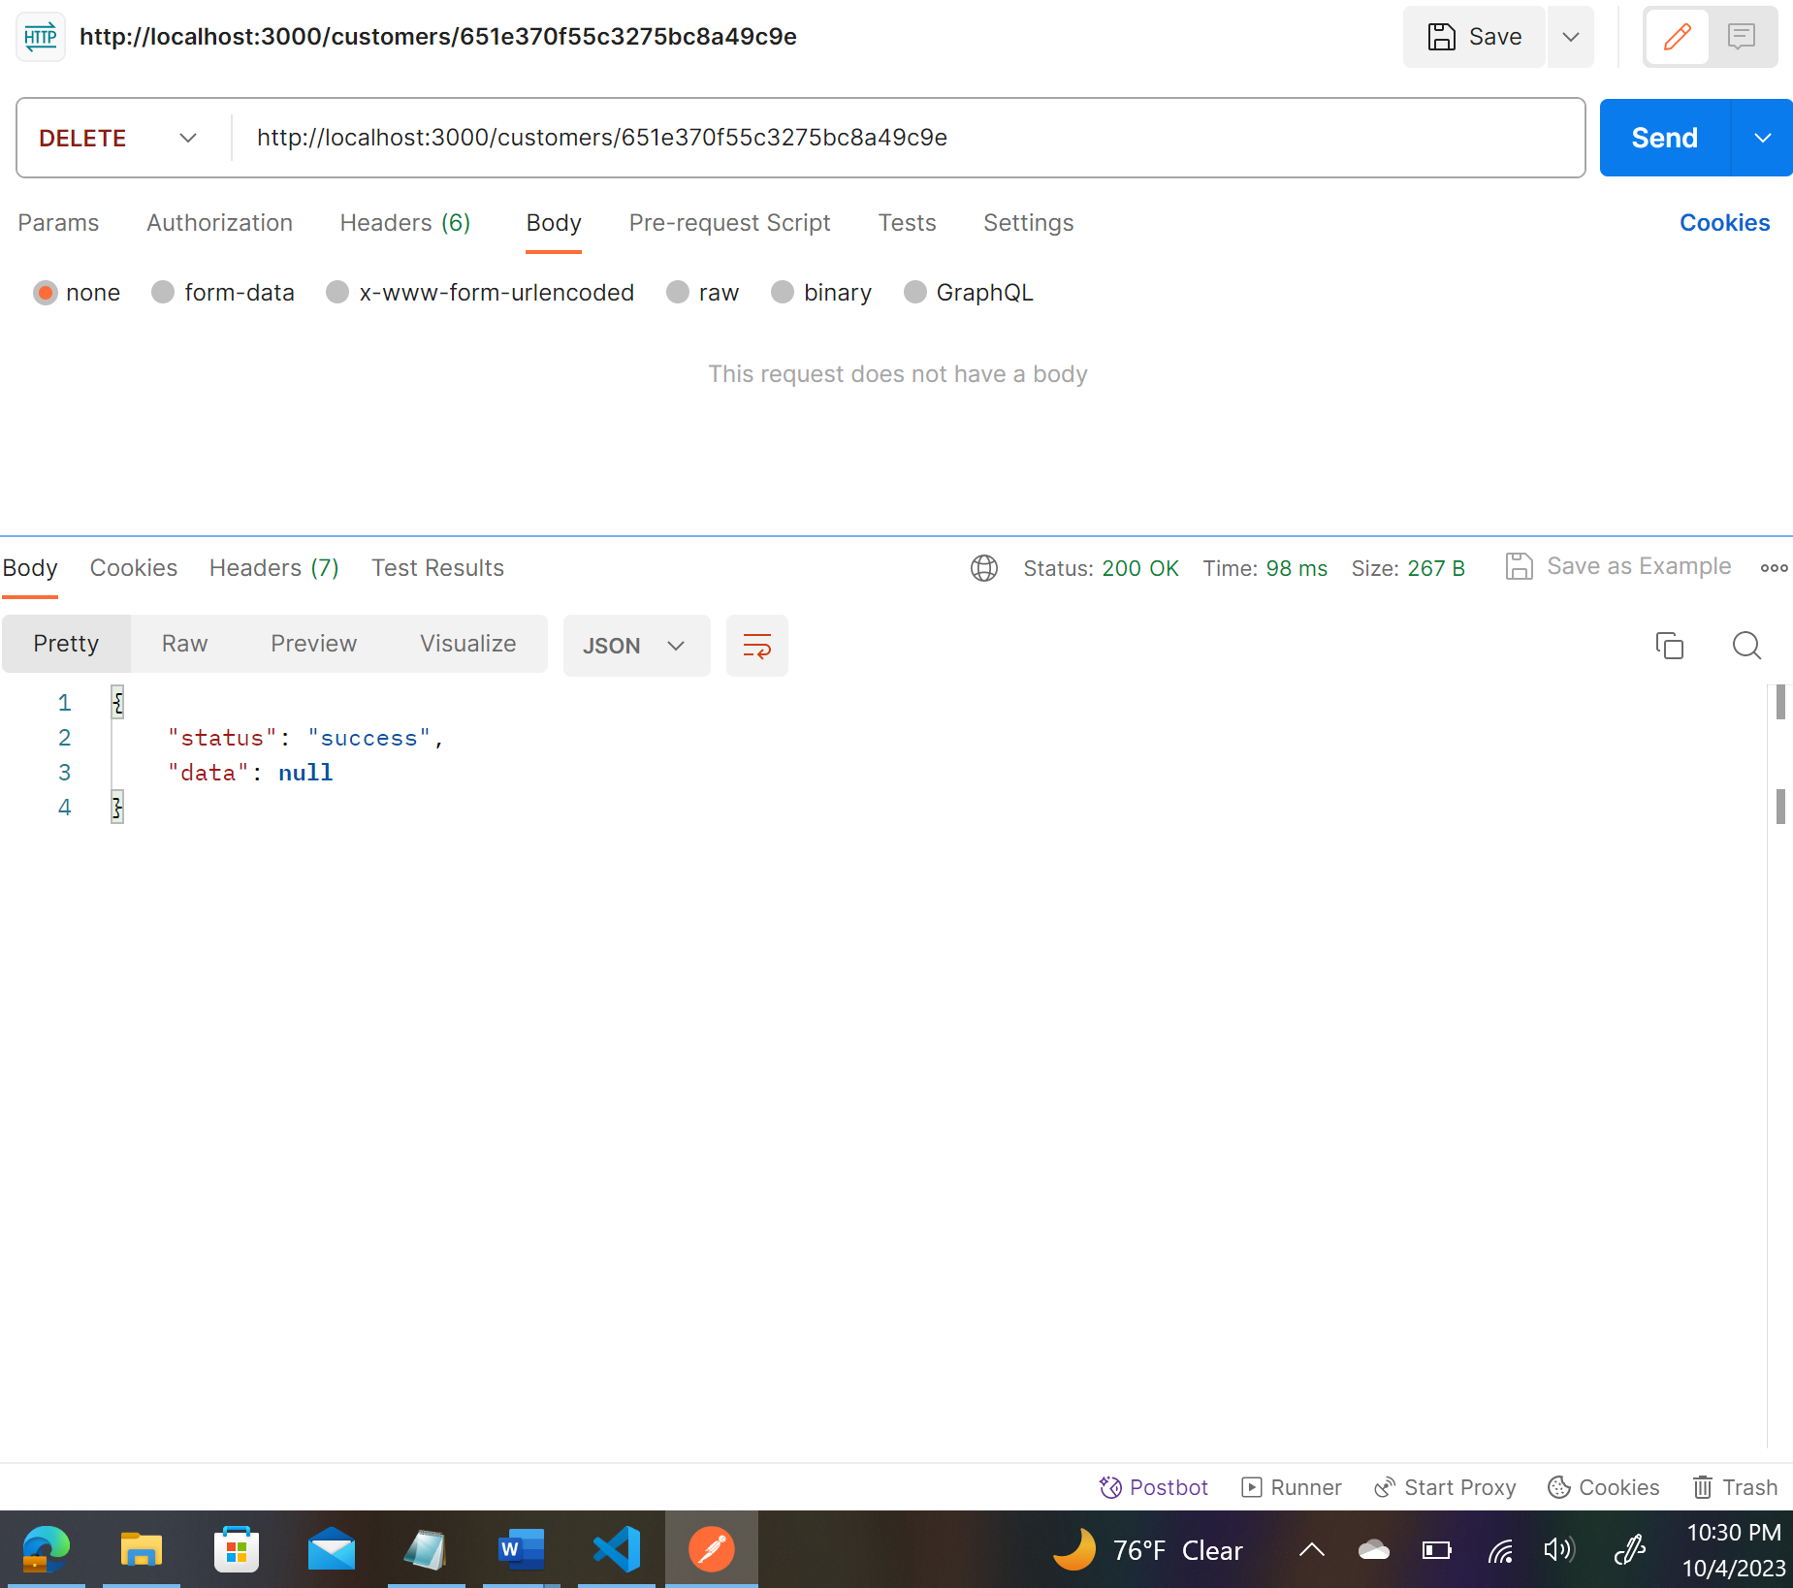

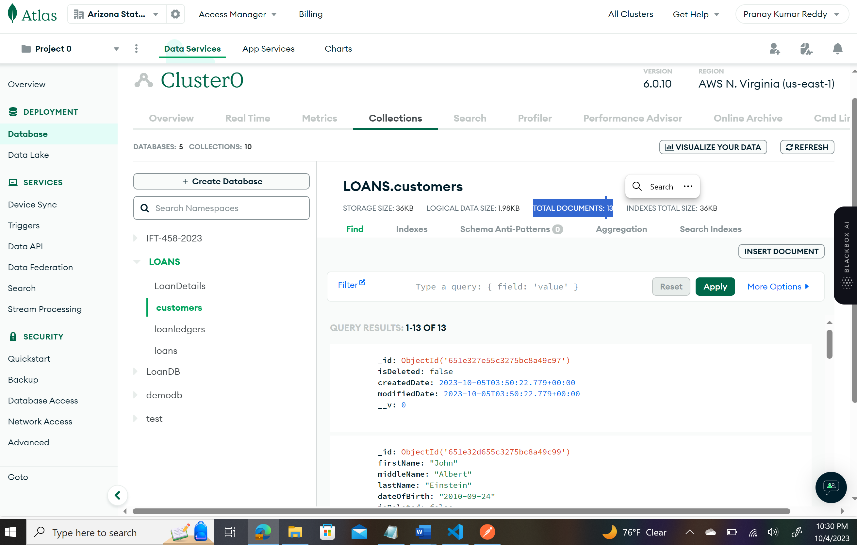

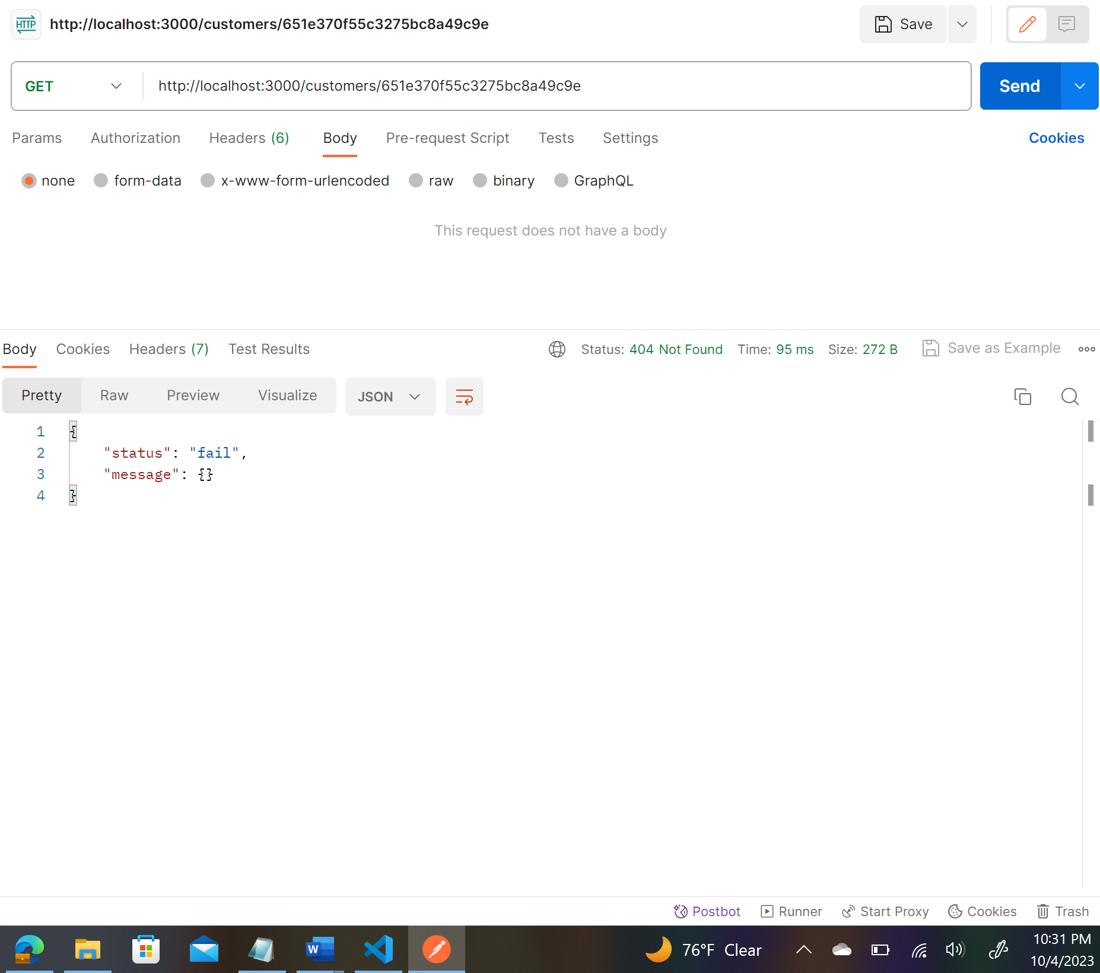

**APIs**:

1. POST /customers: This API helps in storing customers' information in customer collection.
2. GET /customers: Get information on all the customers stored in customers collection.
3. POST /loans: This API helps in storing loan information in loans collection.
4. GET /loans: Get information on all the loans stored in loans collection.
5. POST /loanledger: This API helps in storing customer payments to pay a loan. This information is stored in loanledger collection.
6. GET /loanledger: Get information on all the loanledger stored in loanledger collection.

* The above APIs are served using express. These APIs process the data using controllers and then use Mongoose to validate and store/read data in Mongodb database.